BLOOD BANK MANAGEMENT SYSTEM
A MAJOR PROJECT REPORT

Submitted for the partial fulfillment of
Bachelor of Computer Applications
(3 year Course)


Submitted To- Submitted By-
Dr. Deepak Chahal Rishabh Kumar
Professor BCA (3rd Year) (1st shift)

Jagan Institute of Management Studies
(Affiliated to Guru Gobind Singh Indraprastha University, Sector 16 C, Dwarka, Delhi-110078)

CERTIFICATE

This is to certify that Major Project Practical File being submitted is a bonafide work done by Rishabh Kumar Student of BCA 3rd year 1st shift in partial fulfilment of the award of the BCA degree.
He has worked under my guidance and supervision and has fulfilled the requirements of the file that has reached the requisite standards.

Dr. Deepak Chahal
(Professor)

ACKNOWLEDGEMENT

I Rishabh Kumar, the student of BCA (3rd year) (1st shift) extremely grateful to JIMS college for the confidence bestowed in me and entrusting my Practical file of Major Project.
At this juncture I feel deeply honoured in expressing my sincere thanks to my faculty, Dr. Deepak Chahal for her valuable inputs, her guidance, encouragement and whole-hearted cooperation and constructive criticism throughout the preparation of this practical file.
I place a deep sense of gratitude to my friends and classmates who have been a constant source of inspiration during the preparation of this Major Project Practical file.

Rishabh Kumar
Table of Contents

Chapter 1. Introduction Page No.
- Introduction to the System 7
- Objective 7
- Goal 7
- Need of System 7

Chapter 2. Hardware and Software requirements
- Software requirement 8
- Hardware requirements 8

Chapter 3. System Analysis
- Purpose 9
- Project Scope 9
- Proposed System 9
- Modules 10

Chapter 4.Implementation issues
- JAVA(SWING) 11-12
- MYSQL 12

Chapter 5. System Design

- Use Case Diagram 14
- Class Diagram 15
- Sequence Diagram 16
- Data Flow Diagram of “BloodBank Management” 17-18
- E-R Diagram of “BloodBank Management” 19

Chapter 6.Output Screens 20-27

Chapter 7.Coding 28-90

Chapter 8. Conclusion
- Advantages of “BloodBank Management” 91
- Limitations of “BloodBank Management” 92
- Future Scope of “BloodBank Management” 92
- Conclusion of “BloodBank Management” 92

Bibliography 93

CHAPTER # 1
Introduction
Contents:
- Introduction
- Problem Definition
- Aim
- Objective
- Goal
- Need of System

Introduction to the System:

BLOOD BANK management system is a desktop based application on Java. The purpose of this project was to develop a blood management information system to assist in the management of blood donor records and sells record. This project includes mainly two modules i.e. login and main page.
The current system is manual and it is time-consuming. It is also cost-ineffective, and the average return is low and diminishing.

Objective:

This software helps to easy management of records such as management of blood donors, sells and no. of blood packets available etc.

Goal:

The project is basically targeted at those people who would like offline management software.
To make a database that is consistent, reliable and secure.
To provide correct, complete, ongoing information.
To develop a well-organized information storage system.
To make good documentation so as to facilitate possible future enhancements.

Need of the System:

There is always a need of a system that will help in blood bank to manage information of available blood packets of a corresponding blood group.

CHAPTER # 2
Hardware and Software Requirements

Hardware and Software Specification

Software Requirements:
- Operating System: Windows 7/8/10 etc.
- JDK(Java Development Kit)
- Netbeans IDE(Integrated Development Environment)
- MYSQL Workbench or Xampp
Hardware Requirements:
- Intel Processor 2.0 GHz or above.
- 2 GB RAM or more.
- 160 GB Hard Disk Drive or more.

CHAPTER # 3
System Analysis

Contents:

Purpose
- Project Scope
- Existing System
- Proposed System
- System Overview

Purpose:

The purpose of this project is to provide a way to manage the quantity of available blood packets, donor and buyer information, and also provide a easy interface for management.

Project Scope:

The project has a wide scope, as it is not intended to a particular organization. This project is going to develop generic software, which can be applied by any businesses organization. More over it provides facility to its users. Also the software is going to provide a huge amount of summary data.

Proposed System:

The blood bank management system is available in the market that can serve blood bank owners to easily manage records.
Modules :

- Manage Donor Information
- Manage No. of Blood Packets Available
- Manage Buyer information

CHAPTER # 4
Implementation issues

FrontEnd(Language Used) :
JAVA (swing)

BackEnd(Database Used) :
MYSQL

4.1 JAVA
Java is a programming language and a platform.
Java is a high level, robust, object-oriented and secure programming language.
Platform: Any hardware or software environment in which a program runs, is known as a platform. Since Java has a runtime environment (JRE) and API, it is called a platform.

According to Sun, 3 billion devices run Java. There are many devices where Java is currently used. Some of them are as follows:
- Desktop Applications such as acrobat reader, media player, antivirus, etc.
- Web Applications such as irctc.co.in, javatpoint.com, etc.
- Enterprise Applications such as banking applications.
- Mobile
- Embedded System
- Smart Card
- Robotics
- Games, etc.

MYSQL

MySQL is the most popular Open Source Relational SQL Database Management System. MySQL is one of the best RDBMS being used for developing various web-based software applications. MySQL is developed, marketed and supported by MySQL AB, which is a Swedish company.

CHAPTER # 5
System Design

Contents:

- Use case diagram
- Class Diagram
- Activity Diagram
- Sequence Diagram
- Data flow diagram

Use Case Diagram:
- Use case diagram consists of use cases and actors and shows the interaction between them. The key points are:
- The main purpose is to show the interaction between the use cases and the actor.
- To represent the system requirement from user’s perspective.
- The use cases are the functions that are to be performed in the module.

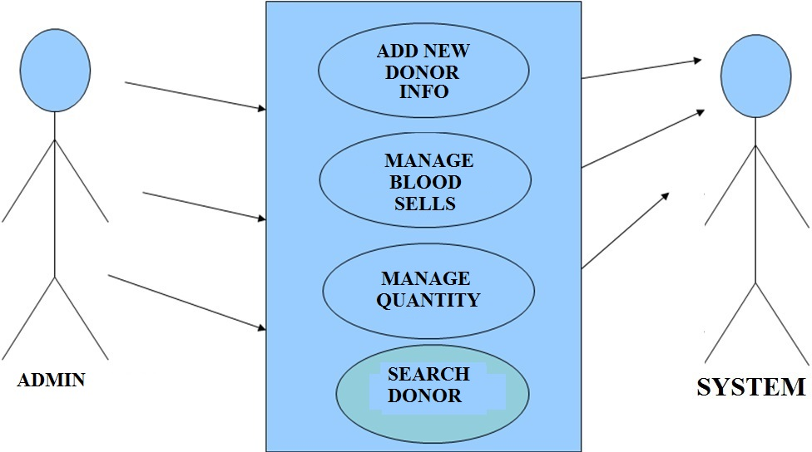

Fig. Use Case Diagram b/w admin and system

Class Diagram of BloodBank Management System

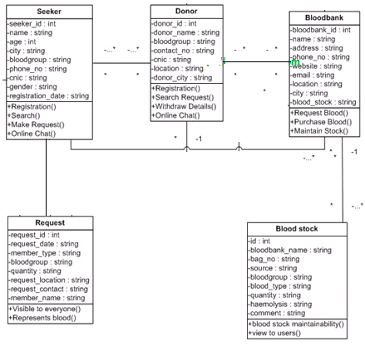
Fig.5.3

Sequence Diagram For Administrator:-

Login
Application
Database
Login
:Request
:Validate()
:executeQuery()
Response
Show Result
Failed:show()
Administrator
Success:hide()

Fig.5.4

Data Flow Diagram
A Data Flow Diagram (DFD) is a graphical representation of the "flow" of data through an Information System. A data flow diagram can also be used for the visualization of Data Processing. It is common practice for a designer to draw a context-level DFD first which shows the interaction between the system and outside entities. This context-level DFD is then "exploded" to show more detail of the system being modeled.
A DFD represents flow of data through a system. Data flow diagrams are commonly used during problem analysis. It views a system as a function that transforms the input into desired output. A DFD shows movement of data through the different transformations or processes in the system.
Dataflow diagrams can be used to provide the end user with a physical idea of where the data they input ultimately has an effect upon the structure of the whole system from order to dispatch to restock how any system is developed can be determined through a dataflow diagram. The appropriate register saved in database and maintained by appropriate authorities.
Data Flow Diagram Notation

Function

File/Database

Input/output

Flow

DFD
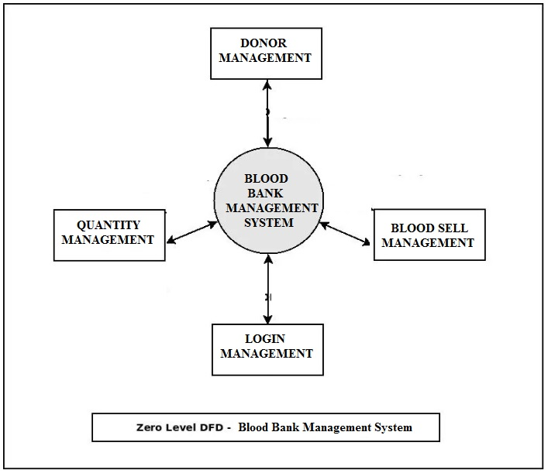

ER DIAGRAM of BloodBank Management System

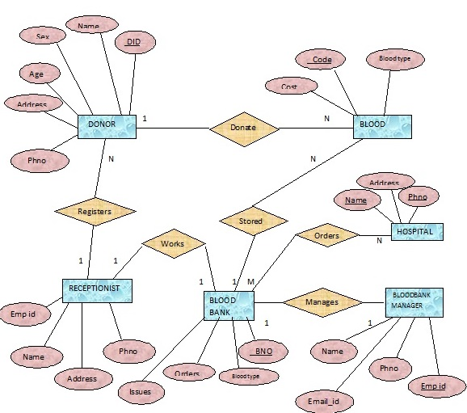

CHAPTER # 6
Output Screens

SPLASHSCREEN FRAME

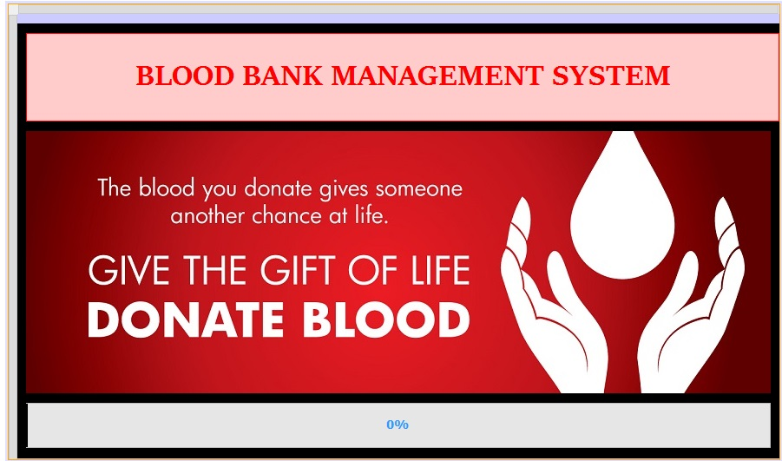

LOGIN FRAME

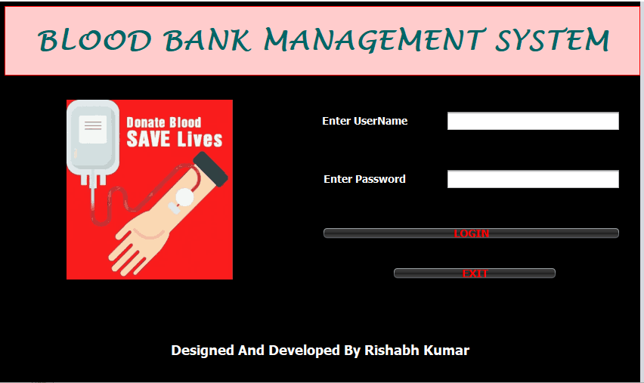

ADMIN DASHBOARD PAGE

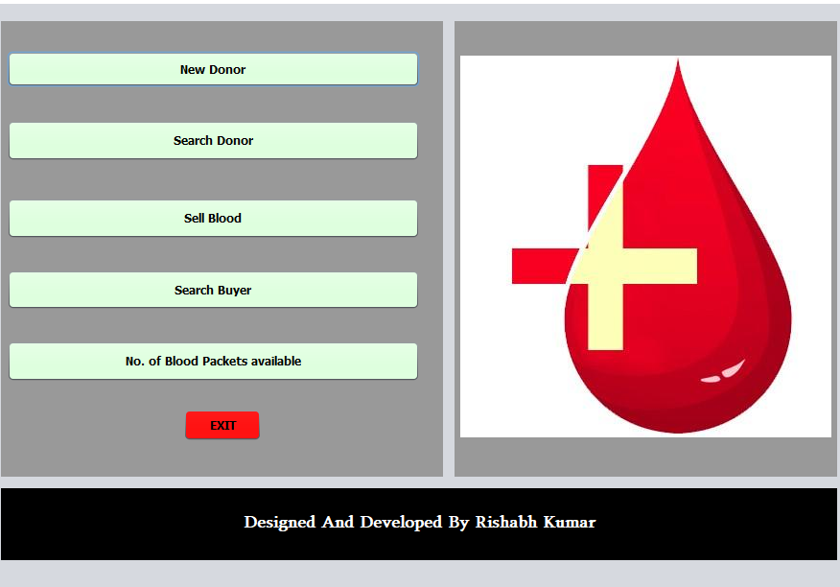

ADD NEWDONOR FRAME

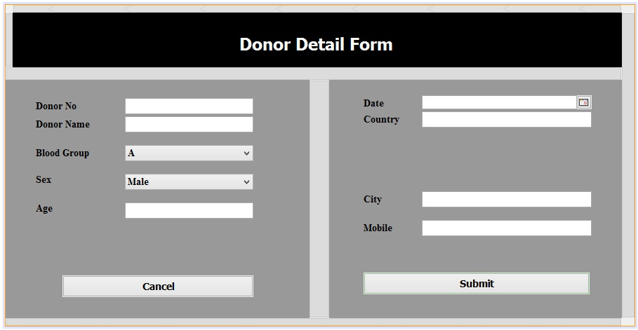

VIEW NO. OF PACKETS AVAILABLE

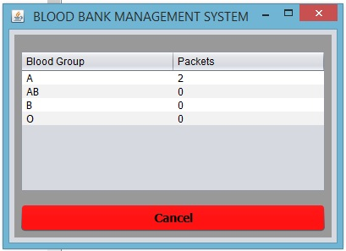

Search Donor

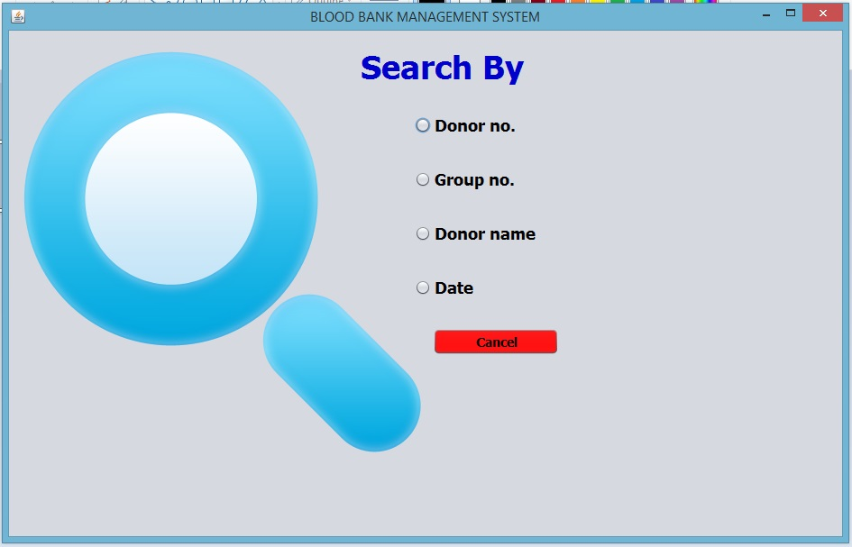

VIEW DONOR FRAME

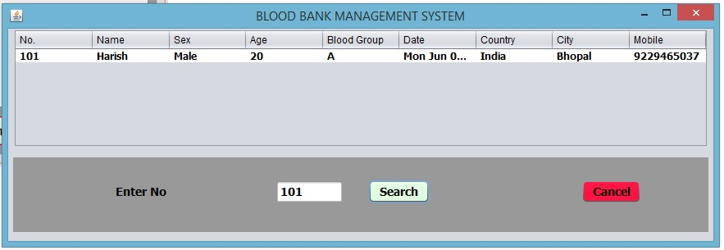

VIEW BUYER FRAME

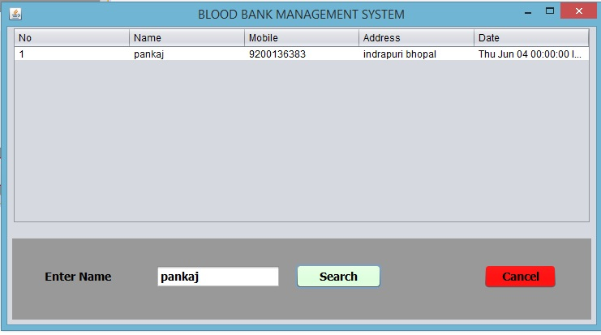

CHAPTER # 7
Coding

SPLASH SCREEN FRAME CODING

package bloodbank;

public class SplashScreenFrame extends javax.swing.JFrame {

private SplashThread sp;
public SplashScreenFrame() {
initComponents();
sp=new SplashThread();
sp.start();
}

class SplashThread extends Thread{
public void run(){
try
{
for(int i = 0 ; i<=100 ; i++)
{
Thread.sleep(100);
jProgressBar1.setValue(i);
}
SplashScreenFrame.this.dispose();
LoginFrame lf=new LoginFrame();
lf.setVisible(true);

}
catch(Exception e)
{

}
}

}
@SuppressWarnings("unchecked")
// <editor-fold defaultstate="collapsed" desc="Generated Code">
private void initComponents() {

jPanel1 = new javax.swing.JPanel();
jPanel3 = new javax.swing.JPanel();
jPanel2 = new javax.swing.JPanel();
jLabel1 = new javax.swing.JLabel();
jLabel2 = new javax.swing.JLabel();
jProgressBar1 = new javax.swing.JProgressBar();

setDefaultCloseOperation(javax.swing.WindowConstants.EXIT_ON_CLOSE);
setUndecorated(true);

jPanel1.setBackground(new java.awt.Color(204, 204, 255));

jPanel3.setBackground(new java.awt.Color(0, 0, 0));

jPanel2.setBackground(new java.awt.Color(255, 204, 204));
jPanel2.setBorder(javax.swing.BorderFactory.createMatteBorder(1, 1, 1, 1, new java.awt.Color(255, 0, 0)));

jLabel1.setFont(new java.awt.Font("Sitka Heading", 1, 36)); // NOI18N
jLabel1.setForeground(new java.awt.Color(255, 0, 0));
jLabel1.setHorizontalAlignment(javax.swing.SwingConstants.CENTER);
jLabel1.setText("BLOOD BANK MANAGEMENT SYSTEM");

javax.swing.GroupLayout jPanel2Layout = new javax.swing.GroupLayout(jPanel2);
jPanel2.setLayout(jPanel2Layout);
jPanel2Layout.setHorizontalGroup(
jPanel2Layout.createParallelGroup(javax.swing.GroupLayout.Alignment.LEADING)
.addGroup(jPanel2Layout.createSequentialGroup()
.addContainerGap()
.addComponent(jLabel1, javax.swing.GroupLayout.DEFAULT_SIZE, 846, Short.MAX_VALUE)
.addContainerGap())
);
jPanel2Layout.setVerticalGroup(
jPanel2Layout.createParallelGroup(javax.swing.GroupLayout.Alignment.LEADING)
.addGroup(javax.swing.GroupLayout.Alignment.TRAILING, jPanel2Layout.createSequentialGroup()
.addContainerGap()
.addComponent(jLabel1, javax.swing.GroupLayout.DEFAULT_SIZE, 78, Short.MAX_VALUE)
.addContainerGap())
);

jLabel2.setIcon(new javax.swing.ImageIcon(getClass().getResource("/image/banner21.jpg"))); // NOI18N

jProgressBar1.setBackground(new java.awt.Color(255, 0, 0));
jProgressBar1.setFont(new java.awt.Font("Tahoma", 1, 14)); // NOI18N
jProgressBar1.setForeground(new java.awt.Color(0, 0, 0));
jProgressBar1.setStringPainted(true);

javax.swing.GroupLayout jPanel3Layout = new javax.swing.GroupLayout(jPanel3);
jPanel3.setLayout(jPanel3Layout);
jPanel3Layout.setHorizontalGroup(
jPanel3Layout.createParallelGroup(javax.swing.GroupLayout.Alignment.LEADING)
.addGroup(jPanel3Layout.createSequentialGroup()
.addContainerGap()
.addGroup(jPanel3Layout.createParallelGroup(javax.swing.GroupLayout.Alignment.LEADING)
.addComponent(jPanel2, javax.swing.GroupLayout.Alignment.TRAILING, javax.swing.GroupLayout.DEFAULT_SIZE, javax.swing.GroupLayout.DEFAULT_SIZE, Short.MAX_VALUE)
.addGroup(javax.swing.GroupLayout.Alignment.TRAILING, jPanel3Layout.createSequentialGroup()
.addGroup(jPanel3Layout.createParallelGroup(javax.swing.GroupLayout.Alignment.TRAILING)
.addComponent(jProgressBar1, javax.swing.GroupLayout.Alignment.LEADING, javax.swing.GroupLayout.DEFAULT_SIZE, javax.swing.GroupLayout.DEFAULT_SIZE, Short.MAX_VALUE)
.addComponent(jLabel2, javax.swing.GroupLayout.PREFERRED_SIZE, 0, Short.MAX_VALUE))
.addContainerGap())))
);
jPanel3Layout.setVerticalGroup(
jPanel3Layout.createParallelGroup(javax.swing.GroupLayout.Alignment.LEADING)
.addGroup(jPanel3Layout.createSequentialGroup()
.addContainerGap()
.addComponent(jPanel2, javax.swing.GroupLayout.PREFERRED_SIZE, javax.swing.GroupLayout.DEFAULT_SIZE, javax.swing.GroupLayout.PREFERRED_SIZE)
.addPreferredGap(javax.swing.LayoutStyle.ComponentPlacement.UNRELATED)
.addComponent(jLabel2, javax.swing.GroupLayout.PREFERRED_SIZE, 302, javax.swing.GroupLayout.PREFERRED_SIZE)
.addPreferredGap(javax.swing.LayoutStyle.ComponentPlacement.UNRELATED)
.addComponent(jProgressBar1, javax.swing.GroupLayout.DEFAULT_SIZE, 53, Short.MAX_VALUE)
.addContainerGap())
);

javax.swing.GroupLayout jPanel1Layout = new javax.swing.GroupLayout(jPanel1);
jPanel1.setLayout(jPanel1Layout);
jPanel1Layout.setHorizontalGroup(
jPanel1Layout.createParallelGroup(javax.swing.GroupLayout.Alignment.LEADING)
.addComponent(jPanel3, javax.swing.GroupLayout.DEFAULT_SIZE, javax.swing.GroupLayout.DEFAULT_SIZE, Short.MAX_VALUE)
);
jPanel1Layout.setVerticalGroup(
jPanel1Layout.createParallelGroup(javax.swing.GroupLayout.Alignment.LEADING)
.addGroup(jPanel1Layout.createSequentialGroup()
.addContainerGap()
.addComponent(jPanel3, javax.swing.GroupLayout.PREFERRED_SIZE, javax.swing.GroupLayout.DEFAULT_SIZE, javax.swing.GroupLayout.PREFERRED_SIZE)
.addContainerGap(javax.swing.GroupLayout.DEFAULT_SIZE, Short.MAX_VALUE))
);

javax.swing.GroupLayout layout = new javax.swing.GroupLayout(getContentPane());
getContentPane().setLayout(layout);
layout.setHorizontalGroup(
layout.createParallelGroup(javax.swing.GroupLayout.Alignment.LEADING)
.addGroup(layout.createSequentialGroup()
.addContainerGap()
.addComponent(jPanel1, javax.swing.GroupLayout.DEFAULT_SIZE, javax.swing.GroupLayout.DEFAULT_SIZE, Short.MAX_VALUE))
);
layout.setVerticalGroup(
layout.createParallelGroup(javax.swing.GroupLayout.Alignment.LEADING)
.addGroup(layout.createSequentialGroup()
.addContainerGap()
.addComponent(jPanel1, javax.swing.GroupLayout.DEFAULT_SIZE, javax.swing.GroupLayout.DEFAULT_SIZE, Short.MAX_VALUE)
.addContainerGap())
);

setSize(new java.awt.Dimension(888, 524));
setLocationRelativeTo(null);
}// </editor-fold>

/**
* @param args the command line arguments
*/
public static void main(String args[]) {
/* Set the Nimbus look and feel */
//<editor-fold defaultstate="collapsed" desc=" Look and feel setting code (optional) ">
/* If Nimbus (introduced in Java SE 6) is not available, stay with the default look and feel.
* For details see http://download.oracle.com/javase/tutorial/uiswing/lookandfeel/plaf.html
*/
try {
for (javax.swing.UIManager.LookAndFeelInfo info : javax.swing.UIManager.getInstalledLookAndFeels()) {
if ("Nimbus".equals(info.getName())) {
javax.swing.UIManager.setLookAndFeel(info.getClassName());
break;
}
}
} catch (ClassNotFoundException ex) {
java.util.logging.Logger.getLogger(SplashScreenFrame.class.getName()).log(java.util.logging.Level.SEVERE, null, ex);
} catch (InstantiationException ex) {
java.util.logging.Logger.getLogger(SplashScreenFrame.class.getName()).log(java.util.logging.Level.SEVERE, null, ex);
} catch (IllegalAccessException ex) {
java.util.logging.Logger.getLogger(SplashScreenFrame.class.getName()).log(java.util.logging.Level.SEVERE, null, ex);
} catch (javax.swing.UnsupportedLookAndFeelException ex) {
java.util.logging.Logger.getLogger(SplashScreenFrame.class.getName()).log(java.util.logging.Level.SEVERE, null, ex);
}
//</editor-fold>

/* Create and display the form */
java.awt.EventQueue.invokeLater(new Runnable() {
public void run() {
new SplashScreenFrame().setVisible(true);
}
});
}

// Variables declaration - do not modify
private javax.swing.JLabel jLabel1;
private javax.swing.JLabel jLabel2;
private javax.swing.JPanel jPanel1;
private javax.swing.JPanel jPanel2;
private javax.swing.JPanel jPanel3;
private javax.swing.JProgressBar jProgressBar1;
// End of variables declaration
}}

LOGIN FRAME CODING

package bloodbank;

import javax.swing.JOptionPane;

public class LoginFrame extends javax.swing.JFrame {

public LoginFrame() {
initComponents();
}

@SuppressWarnings("unchecked")
// <editor-fold defaultstate="collapsed" desc="Generated Code">
private void initComponents() {

jPanel3 = new javax.swing.JPanel();
jPanel2 = new javax.swing.JPanel();
jLabel1 = new javax.swing.JLabel();
jLabel2 = new javax.swing.JLabel();
jLabel3 = new javax.swing.JLabel();
jLabel4 = new javax.swing.JLabel();
jLabel5 = new javax.swing.JLabel();
jTextField1 = new javax.swing.JTextField();
jButton1 = new javax.swing.JButton();
jButton2 = new javax.swing.JButton();
jPasswordField1 = new javax.swing.JPasswordField();

setDefaultCloseOperation(javax.swing.WindowConstants.EXIT_ON_CLOSE);
setTitle("BLOOD BANK MANAGEMENT SYSTEM");

jPanel3.setBackground(new java.awt.Color(0, 0, 0));

jPanel2.setBackground(new java.awt.Color(255, 204, 204));
jPanel2.setBorder(javax.swing.BorderFactory.createMatteBorder(1, 1, 1, 1, new java.awt.Color(255, 0, 0)));

jLabel1.setFont(new java.awt.Font("Sitka Heading", 1, 36)); // NOI18N
jLabel1.setForeground(new java.awt.Color(255, 0, 0));
jLabel1.setHorizontalAlignment(javax.swing.SwingConstants.CENTER);
jLabel1.setText("BLOOD BANK MANAGEMENT SYSTEM");

javax.swing.GroupLayout jPanel2Layout = new javax.swing.GroupLayout(jPanel2);
jPanel2.setLayout(jPanel2Layout);
jPanel2Layout.setHorizontalGroup(
jPanel2Layout.createParallelGroup(javax.swing.GroupLayout.Alignment.LEADING)
.addGroup(jPanel2Layout.createSequentialGroup()
.addContainerGap()
.addComponent(jLabel1, javax.swing.GroupLayout.DEFAULT_SIZE, javax.swing.GroupLayout.DEFAULT_SIZE, Short.MAX_VALUE)
.addContainerGap())
);
jPanel2Layout.setVerticalGroup(
jPanel2Layout.createParallelGroup(javax.swing.GroupLayout.Alignment.LEADING)
.addGroup(javax.swing.GroupLayout.Alignment.TRAILING, jPanel2Layout.createSequentialGroup()
.addContainerGap()
.addComponent(jLabel1, javax.swing.GroupLayout.DEFAULT_SIZE, 78, Short.MAX_VALUE)
.addContainerGap())
);

jLabel2.setIcon(new javax.swing.ImageIcon(getClass().getResource("/image/tenor.gif"))); // NOI18N

jLabel3.setFont(new java.awt.Font("Tahoma", 1, 18)); // NOI18N
jLabel3.setForeground(new java.awt.Color(255, 255, 255));
jLabel3.setHorizontalAlignment(javax.swing.SwingConstants.CENTER);
jLabel3.setText("Designed And Developed By ABC and XYZ");

jLabel4.setFont(new java.awt.Font("Tahoma", 1, 14)); // NOI18N
jLabel4.setForeground(new java.awt.Color(255, 255, 255));
jLabel4.setText("Enter UserName");

jLabel5.setFont(new java.awt.Font("Tahoma", 1, 14)); // NOI18N
jLabel5.setForeground(new java.awt.Color(255, 255, 255));
jLabel5.setHorizontalAlignment(javax.swing.SwingConstants.CENTER);
jLabel5.setText("Enter Password");

jButton1.setBackground(new java.awt.Color(0, 0, 0));
jButton1.setFont(new java.awt.Font("Tahoma", 1, 14)); // NOI18N
jButton1.setForeground(new java.awt.Color(255, 0, 0));
jButton1.setText("LOGIN");
jButton1.setBorder(null);
jButton1.addActionListener(new java.awt.event.ActionListener() {
public void actionPerformed(java.awt.event.ActionEvent evt) {
jButton1ActionPerformed(evt);
}
});

jButton2.setBackground(new java.awt.Color(0, 0, 0));
jButton2.setFont(new java.awt.Font("Tahoma", 1, 14)); // NOI18N
jButton2.setForeground(new java.awt.Color(255, 0, 0));
jButton2.setText("EXIT");
jButton2.setBorder(null);
jButton2.addActionListener(new java.awt.event.ActionListener() {
public void actionPerformed(java.awt.event.ActionEvent evt) {
jButton2ActionPerformed(evt);
}
});

javax.swing.GroupLayout jPanel3Layout = new javax.swing.GroupLayout(jPanel3);
jPanel3.setLayout(jPanel3Layout);
jPanel3Layout.setHorizontalGroup(
jPanel3Layout.createParallelGroup(javax.swing.GroupLayout.Alignment.LEADING)
.addGroup(jPanel3Layout.createSequentialGroup()
.addContainerGap()
.addGroup(jPanel3Layout.createParallelGroup(javax.swing.GroupLayout.Alignment.LEADING)
.addGroup(jPanel3Layout.createSequentialGroup()
.addComponent(jLabel3, javax.swing.GroupLayout.DEFAULT_SIZE, javax.swing.GroupLayout.DEFAULT_SIZE, Short.MAX_VALUE)
.addContainerGap())
.addComponent(jPanel2, javax.swing.GroupLayout.Alignment.TRAILING, javax.swing.GroupLayout.DEFAULT_SIZE, javax.swing.GroupLayout.DEFAULT_SIZE, Short.MAX_VALUE)
.addGroup(jPanel3Layout.createSequentialGroup()
.addGap(82, 82, 82)
.addComponent(jLabel2)
.addGroup(jPanel3Layout.createParallelGroup(javax.swing.GroupLayout.Alignment.LEADING)
.addGroup(jPanel3Layout.createSequentialGroup()
.addGap(118, 118, 118)
.addGroup(jPanel3Layout.createParallelGroup(javax.swing.GroupLayout.Alignment.LEADING, false)
.addGroup(jPanel3Layout.createSequentialGroup()
.addGroup(jPanel3Layout.createParallelGroup(javax.swing.GroupLayout.Alignment.LEADING, false)
.addComponent(jLabel4, javax.swing.GroupLayout.DEFAULT_SIZE, javax.swing.GroupLayout.DEFAULT_SIZE, Short.MAX_VALUE)
.addComponent(jLabel5, javax.swing.GroupLayout.DEFAULT_SIZE, javax.swing.GroupLayout.DEFAULT_SIZE, Short.MAX_VALUE))
.addGap(51, 51, 51)
.addGroup(jPanel3Layout.createParallelGroup(javax.swing.GroupLayout.Alignment.LEADING, false)
.addComponent(jTextField1)
.addComponent(jPasswordField1, javax.swing.GroupLayout.DEFAULT_SIZE, 231, Short.MAX_VALUE)))
.addComponent(jButton1, javax.swing.GroupLayout.DEFAULT_SIZE, javax.swing.GroupLayout.DEFAULT_SIZE, Short.MAX_VALUE)))
.addGroup(jPanel3Layout.createSequentialGroup()
.addGap(211, 211, 211)
.addComponent(jButton2, javax.swing.GroupLayout.PREFERRED_SIZE, 218, javax.swing.GroupLayout.PREFERRED_SIZE)))
.addContainerGap(20, Short.MAX_VALUE))))
);
jPanel3Layout.setVerticalGroup(
jPanel3Layout.createParallelGroup(javax.swing.GroupLayout.Alignment.LEADING)
.addGroup(jPanel3Layout.createSequentialGroup()
.addContainerGap()
.addComponent(jPanel2, javax.swing.GroupLayout.PREFERRED_SIZE, javax.swing.GroupLayout.DEFAULT_SIZE, javax.swing.GroupLayout.PREFERRED_SIZE)
.addGroup(jPanel3Layout.createParallelGroup(javax.swing.GroupLayout.Alignment.LEADING, false)
.addGroup(jPanel3Layout.createSequentialGroup()
.addGap(32, 32, 32)
.addComponent(jLabel2))
.addGroup(jPanel3Layout.createSequentialGroup()
.addGap(46, 46, 46)
.addGroup(jPanel3Layout.createParallelGroup(javax.swing.GroupLayout.Alignment.BASELINE)
.addComponent(jLabel4)
.addComponent(jTextField1, javax.swing.GroupLayout.PREFERRED_SIZE, javax.swing.GroupLayout.DEFAULT_SIZE, javax.swing.GroupLayout.PREFERRED_SIZE))
.addGap(49, 49, 49)
.addGroup(jPanel3Layout.createParallelGroup(javax.swing.GroupLayout.Alignment.BASELINE)
.addComponent(jLabel5)
.addComponent(jPasswordField1, javax.swing.GroupLayout.PREFERRED_SIZE, javax.swing.GroupLayout.DEFAULT_SIZE, javax.swing.GroupLayout.PREFERRED_SIZE))
.addGap(49, 49, 49)
.addComponent(jButton1)
.addPreferredGap(javax.swing.LayoutStyle.ComponentPlacement.RELATED, javax.swing.GroupLayout.DEFAULT_SIZE, Short.MAX_VALUE)
.addComponent(jButton2)))
.addPreferredGap(javax.swing.LayoutStyle.ComponentPlacement.RELATED, 68, Short.MAX_VALUE)
.addComponent(jLabel3, javax.swing.GroupLayout.PREFERRED_SIZE, 36, javax.swing.GroupLayout.PREFERRED_SIZE)
.addGap(25, 25, 25))
);

javax.swing.GroupLayout layout = new javax.swing.GroupLayout(getContentPane());
getContentPane().setLayout(layout);
layout.setHorizontalGroup(
layout.createParallelGroup(javax.swing.GroupLayout.Alignment.LEADING)
.addGroup(javax.swing.GroupLayout.Alignment.TRAILING, layout.createSequentialGroup()
.addComponent(jPanel3, javax.swing.GroupLayout.DEFAULT_SIZE, javax.swing.GroupLayout.DEFAULT_SIZE, Short.MAX_VALUE)
.addContainerGap())
);
layout.setVerticalGroup(
layout.createParallelGroup(javax.swing.GroupLayout.Alignment.LEADING)
.addComponent(jPanel3, javax.swing.GroupLayout.Alignment.TRAILING, javax.swing.GroupLayout.DEFAULT_SIZE, javax.swing.GroupLayout.DEFAULT_SIZE, Short.MAX_VALUE)
);

setSize(new java.awt.Dimension(871, 551));
setLocationRelativeTo(null);
}// </editor-fold>

private void jButton1ActionPerformed(java.awt.event.ActionEvent evt) {
String name = jTextField1.getText();
String password = jPasswordField1.getText();

if(name.equals("admin") && password.equals("admin"))
{
first obj = new first();
//obj.setSize(1400,700);
obj.setVisible(true);
this.dispose();
}
else
{
JOptionPane.showMessageDialog(this , "Login Failed");
}
}

private void jButton2ActionPerformed(java.awt.event.ActionEvent evt) {
System.exit(0);
}

/**
* @param args the command line arguments
*/
public static void main(String args[]) {
/* Set the Nimbus look and feel */
//<editor-fold defaultstate="collapsed" desc=" Look and feel setting code (optional) ">
/* If Nimbus (introduced in Java SE 6) is not available, stay with the default look and feel.
* For details see http://download.oracle.com/javase/tutorial/uiswing/lookandfeel/plaf.html
*/
try {
for (javax.swing.UIManager.LookAndFeelInfo info : javax.swing.UIManager.getInstalledLookAndFeels()) {
if ("Nimbus".equals(info.getName())) {
javax.swing.UIManager.setLookAndFeel(info.getClassName());
break;
}
}
} catch (ClassNotFoundException ex) {
java.util.logging.Logger.getLogger(LoginFrame.class.getName()).log(java.util.logging.Level.SEVERE, null, ex);
} catch (InstantiationException ex) {
java.util.logging.Logger.getLogger(LoginFrame.class.getName()).log(java.util.logging.Level.SEVERE, null, ex);
} catch (IllegalAccessException ex) {
java.util.logging.Logger.getLogger(LoginFrame.class.getName()).log(java.util.logging.Level.SEVERE, null, ex);
} catch (javax.swing.UnsupportedLookAndFeelException ex) {
java.util.logging.Logger.getLogger(LoginFrame.class.getName()).log(java.util.logging.Level.SEVERE, null, ex);
}
//</editor-fold>

/* Create and display the form */
java.awt.EventQueue.invokeLater(new Runnable() {
public void run() {
new LoginFrame().setVisible(true);
}
});
}

// Variables declaration - do not modify
private javax.swing.JButton jButton1;
private javax.swing.JButton jButton2;
private javax.swing.JLabel jLabel1;
private javax.swing.JLabel jLabel2;
private javax.swing.JLabel jLabel3;
private javax.swing.JLabel jLabel4;
private javax.swing.JLabel jLabel5;
private javax.swing.JPanel jPanel2;
private javax.swing.JPanel jPanel3;
private javax.swing.JPasswordField jPasswordField1;
private javax.swing.JTextField jTextField1;
// End of variables declaration
}

ADMIN HOME PAGE FRAME CODING

package bloodbank;

public class first extends javax.swing.JFrame {

public first() {
initComponents();
setLocationRelativeTo(null);

}

@SuppressWarnings("unchecked")
// <editor-fold defaultstate="collapsed" desc="Generated Code">
private void initComponents() {

jLabel1 = new javax.swing.JLabel();
jPanel1 = new javax.swing.JPanel();
jButton1 = new javax.swing.JButton();
jButton2 = new javax.swing.JButton();
jButton3 = new javax.swing.JButton();
jButton6 = new javax.swing.JButton();
jButton7 = new javax.swing.JButton();
jButton5 = new javax.swing.JButton();
jPanel2 = new javax.swing.JPanel();
ll = new javax.swing.JLabel();
jPanel3 = new javax.swing.JPanel();
mm = new javax.swing.JLabel();

setDefaultCloseOperation(javax.swing.WindowConstants.EXIT_ON_CLOSE);

jPanel1.setBackground(new java.awt.Color(153, 153, 153));

jButton1.setBackground(new java.awt.Color(204, 255, 204));
jButton1.setFont(new java.awt.Font("Tahoma", 1, 12)); // NOI18N
jButton1.setText("New Donor");
jButton1.addActionListener(new java.awt.event.ActionListener() {
public void actionPerformed(java.awt.event.ActionEvent evt) {
jButton1ActionPerformed(evt);
}
});

jButton2.setBackground(new java.awt.Color(204, 255, 204));
jButton2.setFont(new java.awt.Font("Tahoma", 1, 12)); // NOI18N
jButton2.setText("Search Donor");
jButton2.addActionListener(new java.awt.event.ActionListener() {
public void actionPerformed(java.awt.event.ActionEvent evt) {
jButton2ActionPerformed(evt);
}
});

jButton3.setBackground(new java.awt.Color(204, 255, 204));
jButton3.setFont(new java.awt.Font("Tahoma", 1, 12)); // NOI18N
jButton3.setText("Sell Blood");
jButton3.addActionListener(new java.awt.event.ActionListener() {
public void actionPerformed(java.awt.event.ActionEvent evt) {
jButton3ActionPerformed(evt);
}
});

jButton6.setBackground(new java.awt.Color(204, 255, 204));
jButton6.setFont(new java.awt.Font("Tahoma", 1, 12)); // NOI18N
jButton6.setText("Search Buyer");
jButton6.addActionListener(new java.awt.event.ActionListener() {
public void actionPerformed(java.awt.event.ActionEvent evt) {
jButton6ActionPerformed(evt);
}
});

jButton7.setBackground(new java.awt.Color(204, 255, 204));
jButton7.setFont(new java.awt.Font("Tahoma", 1, 12)); // NOI18N
jButton7.setText("No. of Blood Packets available");
jButton7.addActionListener(new java.awt.event.ActionListener() {
public void actionPerformed(java.awt.event.ActionEvent evt) {
jButton7ActionPerformed(evt);
}
});

jButton5.setBackground(new java.awt.Color(255, 0, 0));
jButton5.setFont(new java.awt.Font("Tahoma", 1, 12)); // NOI18N
jButton5.setText("EXIT");
jButton5.addActionListener(new java.awt.event.ActionListener() {
public void actionPerformed(java.awt.event.ActionEvent evt) {
jButton5ActionPerformed(evt);
}
});

javax.swing.GroupLayout jPanel1Layout = new javax.swing.GroupLayout(jPanel1);
jPanel1.setLayout(jPanel1Layout);
jPanel1Layout.setHorizontalGroup(
jPanel1Layout.createParallelGroup(javax.swing.GroupLayout.Alignment.LEADING)
.addGroup(jPanel1Layout.createSequentialGroup()
.addContainerGap(javax.swing.GroupLayout.DEFAULT_SIZE, Short.MAX_VALUE)
.addGroup(jPanel1Layout.createParallelGroup(javax.swing.GroupLayout.Alignment.LEADING)
.addGroup(javax.swing.GroupLayout.Alignment.TRAILING, jPanel1Layout.createSequentialGroup()
.addGroup(jPanel1Layout.createParallelGroup(javax.swing.GroupLayout.Alignment.LEADING, false)
.addGroup(jPanel1Layout.createParallelGroup(javax.swing.GroupLayout.Alignment.LEADING, false)
.addComponent(jButton2, javax.swing.GroupLayout.DEFAULT_SIZE, javax.swing.GroupLayout.DEFAULT_SIZE, Short.MAX_VALUE)
.addComponent(jButton1, javax.swing.GroupLayout.DEFAULT_SIZE, javax.swing.GroupLayout.DEFAULT_SIZE, Short.MAX_VALUE)
.addComponent(jButton3, javax.swing.GroupLayout.PREFERRED_SIZE, 431, javax.swing.GroupLayout.PREFERRED_SIZE))
.addComponent(jButton6, javax.swing.GroupLayout.PREFERRED_SIZE, 431, javax.swing.GroupLayout.PREFERRED_SIZE)
.addComponent(jButton7, javax.swing.GroupLayout.PREFERRED_SIZE, 431, javax.swing.GroupLayout.PREFERRED_SIZE))
.addGap(24, 24, 24))
.addGroup(javax.swing.GroupLayout.Alignment.TRAILING, jPanel1Layout.createSequentialGroup()
.addComponent(jButton5, javax.swing.GroupLayout.PREFERRED_SIZE, 82, javax.swing.GroupLayout.PREFERRED_SIZE)
.addGap(189, 189, 189))))
);
jPanel1Layout.setVerticalGroup(
jPanel1Layout.createParallelGroup(javax.swing.GroupLayout.Alignment.LEADING)
.addGroup(jPanel1Layout.createSequentialGroup()
.addGap(31, 31, 31)
.addComponent(jButton1, javax.swing.GroupLayout.PREFERRED_SIZE, 38, javax.swing.GroupLayout.PREFERRED_SIZE)
.addGap(34, 34, 34)
.addComponent(jButton2, javax.swing.GroupLayout.PREFERRED_SIZE, 43, javax.swing.GroupLayout.PREFERRED_SIZE)
.addGap(38, 38, 38)
.addComponent(jButton3, javax.swing.GroupLayout.PREFERRED_SIZE, 43, javax.swing.GroupLayout.PREFERRED_SIZE)
.addGap(32, 32, 32)
.addComponent(jButton6, javax.swing.GroupLayout.PREFERRED_SIZE, 42, javax.swing.GroupLayout.PREFERRED_SIZE)
.addGap(32, 32, 32)
.addComponent(jButton7, javax.swing.GroupLayout.PREFERRED_SIZE, 43, javax.swing.GroupLayout.PREFERRED_SIZE)
.addGap(28, 28, 28)
.addComponent(jButton5, javax.swing.GroupLayout.PREFERRED_SIZE, 34, javax.swing.GroupLayout.PREFERRED_SIZE)
.addContainerGap(37, Short.MAX_VALUE))
);

jPanel2.setBackground(new java.awt.Color(153, 153, 153));

ll.setIcon(new javax.swing.ImageIcon(getClass().getResource("/image/Blood-Donation.jpg"))); // NOI18N

javax.swing.GroupLayout jPanel2Layout = new javax.swing.GroupLayout(jPanel2);
jPanel2.setLayout(jPanel2Layout);
jPanel2Layout.setHorizontalGroup(
jPanel2Layout.createParallelGroup(javax.swing.GroupLayout.Alignment.LEADING)
.addGroup(javax.swing.GroupLayout.Alignment.TRAILING, jPanel2Layout.createSequentialGroup()
.addContainerGap()
.addComponent(ll, javax.swing.GroupLayout.PREFERRED_SIZE, 387, Short.MAX_VALUE)
.addContainerGap())
);
jPanel2Layout.setVerticalGroup(
jPanel2Layout.createParallelGroup(javax.swing.GroupLayout.Alignment.LEADING)
.addGroup(jPanel2Layout.createSequentialGroup()
.addGap(36, 36, 36)
.addComponent(ll)
.addContainerGap(41, Short.MAX_VALUE))
);

jPanel3.setBackground(new java.awt.Color(0, 0, 0));
jPanel3.setToolTipText("");

mm.setFont(new java.awt.Font("Sylfaen", 1, 18)); // NOI18N
mm.setForeground(new java.awt.Color(255, 255, 255));
mm.setHorizontalAlignment(javax.swing.SwingConstants.CENTER);
mm.setText("Designed And Developed By ABC and XYZ");

javax.swing.GroupLayout jPanel3Layout = new javax.swing.GroupLayout(jPanel3);
jPanel3.setLayout(jPanel3Layout);
jPanel3Layout.setHorizontalGroup(
jPanel3Layout.createParallelGroup(javax.swing.GroupLayout.Alignment.LEADING)
.addGroup(jPanel3Layout.createSequentialGroup()
.addContainerGap()
.addComponent(mm, javax.swing.GroupLayout.DEFAULT_SIZE, javax.swing.GroupLayout.DEFAULT_SIZE, Short.MAX_VALUE)
.addContainerGap())
);
jPanel3Layout.setVerticalGroup(
jPanel3Layout.createParallelGroup(javax.swing.GroupLayout.Alignment.LEADING)
.addGroup(jPanel3Layout.createSequentialGroup()
.addContainerGap()
.addComponent(mm, javax.swing.GroupLayout.PREFERRED_SIZE, 63, javax.swing.GroupLayout.PREFERRED_SIZE)
.addContainerGap(javax.swing.GroupLayout.DEFAULT_SIZE, Short.MAX_VALUE))
);

javax.swing.GroupLayout layout = new javax.swing.GroupLayout(getContentPane());
getContentPane().setLayout(layout);
layout.setHorizontalGroup(
layout.createParallelGroup(javax.swing.GroupLayout.Alignment.LEADING)
.addGroup(layout.createSequentialGroup()
.addGap(4, 4, 4)
.addGroup(layout.createParallelGroup(javax.swing.GroupLayout.Alignment.LEADING)
.addGroup(layout.createSequentialGroup()
.addComponent(jLabel1)
.addGap(0, 0, Short.MAX_VALUE))
.addGroup(layout.createSequentialGroup()
.addComponent(jPanel1, javax.swing.GroupLayout.PREFERRED_SIZE, javax.swing.GroupLayout.DEFAULT_SIZE, javax.swing.GroupLayout.PREFERRED_SIZE)
.addPreferredGap(javax.swing.LayoutStyle.ComponentPlacement.UNRELATED)
.addComponent(jPanel2, javax.swing.GroupLayout.PREFERRED_SIZE, javax.swing.GroupLayout.DEFAULT_SIZE, javax.swing.GroupLayout.PREFERRED_SIZE)
.addGap(0, 0, Short.MAX_VALUE))
.addComponent(jPanel3, javax.swing.GroupLayout.DEFAULT_SIZE, javax.swing.GroupLayout.DEFAULT_SIZE, Short.MAX_VALUE))
.addContainerGap())
);
layout.setVerticalGroup(
layout.createParallelGroup(javax.swing.GroupLayout.Alignment.LEADING)
.addGroup(layout.createSequentialGroup()
.addGap(18, 18, 18)
.addGroup(layout.createParallelGroup(javax.swing.GroupLayout.Alignment.LEADING)
.addComponent(jPanel2, javax.swing.GroupLayout.PREFERRED_SIZE, javax.swing.GroupLayout.DEFAULT_SIZE, javax.swing.GroupLayout.PREFERRED_SIZE)
.addComponent(jPanel1, javax.swing.GroupLayout.PREFERRED_SIZE, javax.swing.GroupLayout.DEFAULT_SIZE, javax.swing.GroupLayout.PREFERRED_SIZE))
.addPreferredGap(javax.swing.LayoutStyle.ComponentPlacement.UNRELATED)
.addComponent(jPanel3, javax.swing.GroupLayout.DEFAULT_SIZE, javax.swing.GroupLayout.DEFAULT_SIZE, Short.MAX_VALUE)
.addPreferredGap(javax.swing.LayoutStyle.ComponentPlacement.RELATED)
.addComponent(jLabel1)
.addGap(25, 25, 25))
);

pack();
}// </editor-fold>

private void jButton1ActionPerformed(java.awt.event.ActionEvent evt) {
newdonor obj1=new newdonor();
obj1.setVisible(true);
this.dispose();
}

private void jButton5ActionPerformed(java.awt.event.ActionEvent evt) {
this.dispose();
}

private void jButton3ActionPerformed(java.awt.event.ActionEvent evt) {
sold zx=new sold();
zx.setVisible(true);
this.dispose();
}

private void jButton6ActionPerformed(java.awt.event.ActionEvent evt) {
search3 kk=new search3();
kk.setVisible(true);
this.dispose();
}

private void jButton2ActionPerformed(java.awt.event.ActionEvent evt) {
search obj=new search();
obj.setVisible(true);
this.dispose();
}

private void jButton7ActionPerformed(java.awt.event.ActionEvent evt) {
packets obj=new packets();
obj.setVisible(true);
this.dispose();
}

/**
* @param args the command line arguments
*/
public static void main(String args[]) {
/* Set the Nimbus look and feel */
//<editor-fold defaultstate="collapsed" desc=" Look and feel setting code (optional) ">
/* If Nimbus (introduced in Java SE 6) is not available, stay with the default look and feel.
* For details see http://download.oracle.com/javase/tutorial/uiswing/lookandfeel/plaf.html
*/
try {
for (javax.swing.UIManager.LookAndFeelInfo info : javax.swing.UIManager.getInstalledLookAndFeels()) {
if ("Nimbus".equals(info.getName())) {
javax.swing.UIManager.setLookAndFeel(info.getClassName());
break;
}
}
} catch (ClassNotFoundException ex) {
java.util.logging.Logger.getLogger(first.class.getName()).log(java.util.logging.Level.SEVERE, null, ex);
} catch (InstantiationException ex) {
java.util.logging.Logger.getLogger(first.class.getName()).log(java.util.logging.Level.SEVERE, null, ex);
} catch (IllegalAccessException ex) {
java.util.logging.Logger.getLogger(first.class.getName()).log(java.util.logging.Level.SEVERE, null, ex);
} catch (javax.swing.UnsupportedLookAndFeelException ex) {
java.util.logging.Logger.getLogger(first.class.getName()).log(java.util.logging.Level.SEVERE, null, ex);
}
//</editor-fold>

/* Create and display the form */
java.awt.EventQueue.invokeLater(new Runnable() {
public void run() {

new first().setVisible(true);

}
});
}

// Variables declaration - do not modify
private javax.swing.JButton jButton1;
private javax.swing.JButton jButton2;
private javax.swing.JButton jButton3;
private javax.swing.JButton jButton5;
private javax.swing.JButton jButton6;
private javax.swing.JButton jButton7;
private javax.swing.JLabel jLabel1;
private javax.swing.JPanel jPanel1;
private javax.swing.JPanel jPanel2;
private javax.swing.JPanel jPanel3;
private javax.swing.JLabel ll;
private javax.swing.JLabel mm;
// End of variables declaration
}

ADD NEWDONOR FRAME CODING

package bloodbank;

import java.sql.Connection;
import java.sql.DriverManager;
import java.sql.PreparedStatement;
import java.sql.ResultSet;
import javax.swing.JOptionPane;

public class newdonor extends javax.swing.JFrame {

public static String u;

public static String kk;
public newdonor() {
initComponents();
setLocationRelativeTo(null);

}

/**
* This method is called from within the constructor to initialize the form.
* WARNING: Do NOT modify this code. The content of this method is always
* regenerated by the Form Editor.
*/
@SuppressWarnings("unchecked")
// <editor-fold defaultstate="collapsed" desc="Generated Code">
private void initComponents() {

jPanel1 = new javax.swing.JPanel();
jLabel8 = new javax.swing.JLabel();
t2 = new javax.swing.JTextField();
jLabel2 = new javax.swing.JLabel();
jLabel3 = new javax.swing.JLabel();
t1 = new javax.swing.JTextField();
t3 = new javax.swing.JComboBox();
jLabel6 = new javax.swing.JLabel();
t9 = new javax.swing.JTextField();
jLabel7 = new javax.swing.JLabel();
jButton2 = new javax.swing.JButton();
t4 = new javax.swing.JComboBox();
jPanel2 = new javax.swing.JPanel();
jLabel9 = new javax.swing.JLabel();
t6 = new javax.swing.JTextField();
jLabel4 = new javax.swing.JLabel();
t7 = new javax.swing.JTextField();
jLabel5 = new javax.swing.JLabel();
jLabel10 = new javax.swing.JLabel();
t8 = new javax.swing.JTextField();
jDateChooser1 = new com.toedter.calendar.JDateChooser();
jButton1 = new javax.swing.JButton();
jPanel3 = new javax.swing.JPanel();
jLabel1 = new javax.swing.JLabel();

setDefaultCloseOperation(javax.swing.WindowConstants.EXIT_ON_CLOSE);
setTitle("BLOOD BANK MANAGEMENT SYSTEM");

jPanel1.setBackground(new java.awt.Color(153, 153, 153));

jLabel8.setFont(new java.awt.Font("Times New Roman", 1, 14)); // NOI18N
jLabel8.setText("Donor Name");

t2.setFont(new java.awt.Font("Times New Roman", 1, 14)); // NOI18N

jLabel2.setFont(new java.awt.Font("Times New Roman", 1, 14)); // NOI18N
jLabel2.setText("Donor No");

jLabel3.setFont(new java.awt.Font("Times New Roman", 1, 14)); // NOI18N
jLabel3.setText("Blood Group");

t1.setFont(new java.awt.Font("Times New Roman", 1, 14)); // NOI18N

t3.setFont(new java.awt.Font("Times New Roman", 1, 14)); // NOI18N
t3.setModel(new javax.swing.DefaultComboBoxModel(new String[] { "A", "B", "AB", "O", " " }));

jLabel6.setFont(new java.awt.Font("Times New Roman", 1, 14)); // NOI18N
jLabel6.setText("Age");

t9.setFont(new java.awt.Font("Times New Roman", 1, 14)); // NOI18N
t9.addActionListener(new java.awt.event.ActionListener() {
public void actionPerformed(java.awt.event.ActionEvent evt) {
t9ActionPerformed(evt);
}
});

jLabel7.setFont(new java.awt.Font("Times New Roman", 1, 14)); // NOI18N
jLabel7.setText("Sex");

jButton2.setFont(new java.awt.Font("Tahoma", 1, 14)); // NOI18N
jButton2.setText("Cancel");
jButton2.addActionListener(new java.awt.event.ActionListener() {
public void actionPerformed(java.awt.event.ActionEvent evt) {
jButton2ActionPerformed(evt);
}
});

t4.setFont(new java.awt.Font("Times New Roman", 1, 14)); // NOI18N
t4.setModel(new javax.swing.DefaultComboBoxModel(new String[] { "Male", "Female", " " }));

javax.swing.GroupLayout jPanel1Layout = new javax.swing.GroupLayout(jPanel1);
jPanel1.setLayout(jPanel1Layout);
jPanel1Layout.setHorizontalGroup(
jPanel1Layout.createParallelGroup(javax.swing.GroupLayout.Alignment.LEADING)
.addGroup(jPanel1Layout.createSequentialGroup()
.addGroup(jPanel1Layout.createParallelGroup(javax.swing.GroupLayout.Alignment.TRAILING)
.addGroup(jPanel1Layout.createSequentialGroup()
.addGap(81, 81, 81)
.addComponent(jButton2, javax.swing.GroupLayout.PREFERRED_SIZE, 272, javax.swing.GroupLayout.PREFERRED_SIZE))
.addGroup(jPanel1Layout.createSequentialGroup()
.addGap(43, 43, 43)
.addGroup(jPanel1Layout.createParallelGroup(javax.swing.GroupLayout.Alignment.LEADING, false)
.addComponent(jLabel8, javax.swing.GroupLayout.DEFAULT_SIZE, 115, Short.MAX_VALUE)
.addComponent(jLabel2, javax.swing.GroupLayout.PREFERRED_SIZE, 93, javax.swing.GroupLayout.PREFERRED_SIZE)
.addComponent(jLabel3, javax.swing.GroupLayout.PREFERRED_SIZE, 114, javax.swing.GroupLayout.PREFERRED_SIZE)
.addComponent(jLabel7, javax.swing.GroupLayout.DEFAULT_SIZE, javax.swing.GroupLayout.DEFAULT_SIZE, Short.MAX_VALUE)
.addComponent(jLabel6, javax.swing.GroupLayout.DEFAULT_SIZE, javax.swing.GroupLayout.DEFAULT_SIZE, Short.MAX_VALUE))
.addPreferredGap(javax.swing.LayoutStyle.ComponentPlacement.RELATED, javax.swing.GroupLayout.DEFAULT_SIZE, Short.MAX_VALUE)
.addGroup(jPanel1Layout.createParallelGroup(javax.swing.GroupLayout.Alignment.LEADING)
.addComponent(t9, javax.swing.GroupLayout.PREFERRED_SIZE, 183, javax.swing.GroupLayout.PREFERRED_SIZE)
.addComponent(t1, javax.swing.GroupLayout.PREFERRED_SIZE, 183, javax.swing.GroupLayout.PREFERRED_SIZE)
.addComponent(t2, javax.swing.GroupLayout.PREFERRED_SIZE, 183, javax.swing.GroupLayout.PREFERRED_SIZE)
.addComponent(t3, javax.swing.GroupLayout.PREFERRED_SIZE, 183, javax.swing.GroupLayout.PREFERRED_SIZE)
.addComponent(t4, javax.swing.GroupLayout.PREFERRED_SIZE, 183, javax.swing.GroupLayout.PREFERRED_SIZE))))
.addContainerGap(80, Short.MAX_VALUE))
);
jPanel1Layout.setVerticalGroup(
jPanel1Layout.createParallelGroup(javax.swing.GroupLayout.Alignment.LEADING)
.addGroup(jPanel1Layout.createSequentialGroup()
.addGap(26, 26, 26)
.addGroup(jPanel1Layout.createParallelGroup(javax.swing.GroupLayout.Alignment.BASELINE)
.addComponent(jLabel2, javax.swing.GroupLayout.PREFERRED_SIZE, 21, javax.swing.GroupLayout.PREFERRED_SIZE)
.addComponent(t1, javax.swing.GroupLayout.PREFERRED_SIZE, javax.swing.GroupLayout.DEFAULT_SIZE, javax.swing.GroupLayout.PREFERRED_SIZE))
.addGap(3, 3, 3)
.addGroup(jPanel1Layout.createParallelGroup(javax.swing.GroupLayout.Alignment.BASELINE)
.addComponent(jLabel8)
.addComponent(t2, javax.swing.GroupLayout.PREFERRED_SIZE, javax.swing.GroupLayout.DEFAULT_SIZE, javax.swing.GroupLayout.PREFERRED_SIZE))
.addGap(18, 18, 18)
.addGroup(jPanel1Layout.createParallelGroup(javax.swing.GroupLayout.Alignment.BASELINE)
.addComponent(jLabel3)
.addComponent(t3, javax.swing.GroupLayout.PREFERRED_SIZE, javax.swing.GroupLayout.DEFAULT_SIZE, javax.swing.GroupLayout.PREFERRED_SIZE))
.addGap(18, 18, 18)
.addGroup(jPanel1Layout.createParallelGroup(javax.swing.GroupLayout.Alignment.LEADING)
.addComponent(jLabel7)
.addComponent(t4, javax.swing.GroupLayout.PREFERRED_SIZE, javax.swing.GroupLayout.DEFAULT_SIZE, javax.swing.GroupLayout.PREFERRED_SIZE))
.addGap(18, 18, 18)
.addGroup(jPanel1Layout.createParallelGroup(javax.swing.GroupLayout.Alignment.LEADING)
.addComponent(jLabel6)
.addComponent(t9, javax.swing.GroupLayout.PREFERRED_SIZE, javax.swing.GroupLayout.DEFAULT_SIZE, javax.swing.GroupLayout.PREFERRED_SIZE))
.addPreferredGap(javax.swing.LayoutStyle.ComponentPlacement.RELATED, 81, Short.MAX_VALUE)
.addComponent(jButton2, javax.swing.GroupLayout.PREFERRED_SIZE, 31, javax.swing.GroupLayout.PREFERRED_SIZE)
.addGap(30, 30, 30))
);

jPanel2.setBackground(new java.awt.Color(153, 153, 153));

jLabel9.setFont(new java.awt.Font("Times New Roman", 1, 14)); // NOI18N
jLabel9.setText("City");

t6.setFont(new java.awt.Font("Times New Roman", 1, 14)); // NOI18N

jLabel4.setFont(new java.awt.Font("Times New Roman", 1, 14)); // NOI18N
jLabel4.setText("Date");

t7.setFont(new java.awt.Font("Times New Roman", 1, 14)); // NOI18N

jLabel5.setFont(new java.awt.Font("Times New Roman", 1, 14)); // NOI18N
jLabel5.setText("Country");

jLabel10.setFont(new java.awt.Font("Times New Roman", 1, 14)); // NOI18N
jLabel10.setText("Mobile");

t8.setFont(new java.awt.Font("Times New Roman", 1, 14)); // NOI18N

jButton1.setBackground(new java.awt.Color(204, 255, 204));
jButton1.setFont(new java.awt.Font("Tahoma", 1, 14)); // NOI18N
jButton1.setText("Submit");
jButton1.addActionListener(new java.awt.event.ActionListener() {
public void actionPerformed(java.awt.event.ActionEvent evt) {
jButton1ActionPerformed(evt);
}
});

javax.swing.GroupLayout jPanel2Layout = new javax.swing.GroupLayout(jPanel2);
jPanel2.setLayout(jPanel2Layout);
jPanel2Layout.setHorizontalGroup(
jPanel2Layout.createParallelGroup(javax.swing.GroupLayout.Alignment.LEADING)
.addGroup(jPanel2Layout.createSequentialGroup()
.addGap(49, 49, 49)
.addGroup(jPanel2Layout.createParallelGroup(javax.swing.GroupLayout.Alignment.LEADING, false)
.addGroup(jPanel2Layout.createSequentialGroup()
.addComponent(jLabel4, javax.swing.GroupLayout.PREFERRED_SIZE, 79, javax.swing.GroupLayout.PREFERRED_SIZE)
.addPreferredGap(javax.swing.LayoutStyle.ComponentPlacement.RELATED, javax.swing.GroupLayout.DEFAULT_SIZE, Short.MAX_VALUE)
.addComponent(jDateChooser1, javax.swing.GroupLayout.PREFERRED_SIZE, 242, javax.swing.GroupLayout.PREFERRED_SIZE))
.addGroup(jPanel2Layout.createSequentialGroup()
.addGroup(jPanel2Layout.createParallelGroup(javax.swing.GroupLayout.Alignment.LEADING)
.addComponent(jLabel5, javax.swing.GroupLayout.DEFAULT_SIZE, javax.swing.GroupLayout.DEFAULT_SIZE, Short.MAX_VALUE)
.addComponent(jLabel10, javax.swing.GroupLayout.PREFERRED_SIZE, 70, javax.swing.GroupLayout.PREFERRED_SIZE)
.addComponent(jLabel9, javax.swing.GroupLayout.DEFAULT_SIZE, javax.swing.GroupLayout.DEFAULT_SIZE, Short.MAX_VALUE))
.addPreferredGap(javax.swing.LayoutStyle.ComponentPlacement.UNRELATED)
.addGroup(jPanel2Layout.createParallelGroup(javax.swing.GroupLayout.Alignment.LEADING)
.addComponent(t8, javax.swing.GroupLayout.PREFERRED_SIZE, 242, javax.swing.GroupLayout.PREFERRED_SIZE)
.addComponent(t7, javax.swing.GroupLayout.PREFERRED_SIZE, 242, javax.swing.GroupLayout.PREFERRED_SIZE)
.addComponent(t6, javax.swing.GroupLayout.Alignment.TRAILING, javax.swing.GroupLayout.PREFERRED_SIZE, 242, javax.swing.GroupLayout.PREFERRED_SIZE)))
.addComponent(jButton1, javax.swing.GroupLayout.PREFERRED_SIZE, 322, javax.swing.GroupLayout.PREFERRED_SIZE))
.addContainerGap(43, Short.MAX_VALUE))
);
jPanel2Layout.setVerticalGroup(
jPanel2Layout.createParallelGroup(javax.swing.GroupLayout.Alignment.LEADING)
.addGroup(jPanel2Layout.createSequentialGroup()
.addGap(22, 22, 22)
.addGroup(jPanel2Layout.createParallelGroup(javax.swing.GroupLayout.Alignment.TRAILING)
.addComponent(jLabel4)
.addComponent(jDateChooser1, javax.swing.GroupLayout.PREFERRED_SIZE, javax.swing.GroupLayout.DEFAULT_SIZE, javax.swing.GroupLayout.PREFERRED_SIZE))
.addGroup(jPanel2Layout.createParallelGroup(javax.swing.GroupLayout.Alignment.LEADING)
.addGroup(javax.swing.GroupLayout.Alignment.TRAILING, jPanel2Layout.createSequentialGroup()
.addGap(58, 58, 58)
.addGroup(jPanel2Layout.createParallelGroup(javax.swing.GroupLayout.Alignment.BASELINE)
.addComponent(jLabel9)
.addComponent(t7, javax.swing.GroupLayout.PREFERRED_SIZE, javax.swing.GroupLayout.DEFAULT_SIZE, javax.swing.GroupLayout.PREFERRED_SIZE))
.addGap(18, 18, 18)
.addGroup(jPanel2Layout.createParallelGroup(javax.swing.GroupLayout.Alignment.BASELINE)
.addComponent(jLabel10)
.addComponent(t8, javax.swing.GroupLayout.PREFERRED_SIZE, javax.swing.GroupLayout.DEFAULT_SIZE, javax.swing.GroupLayout.PREFERRED_SIZE))
.addGap(52, 52, 52))
.addGroup(jPanel2Layout.createSequentialGroup()
.addGap(3, 3, 3)
.addGroup(jPanel2Layout.createParallelGroup(javax.swing.GroupLayout.Alignment.BASELINE)
.addComponent(jLabel5)
.addComponent(t6, javax.swing.GroupLayout.PREFERRED_SIZE, javax.swing.GroupLayout.DEFAULT_SIZE, javax.swing.GroupLayout.PREFERRED_SIZE))
.addPreferredGap(javax.swing.LayoutStyle.ComponentPlacement.RELATED, javax.swing.GroupLayout.DEFAULT_SIZE, Short.MAX_VALUE)))
.addComponent(jButton1, javax.swing.GroupLayout.PREFERRED_SIZE, 31, javax.swing.GroupLayout.PREFERRED_SIZE)
.addGap(34, 34, 34))
);

jPanel3.setBackground(new java.awt.Color(0, 0, 0));

jLabel1.setFont(new java.awt.Font("Tahoma", 1, 24)); // NOI18N
jLabel1.setForeground(new java.awt.Color(255, 255, 255));
jLabel1.setHorizontalAlignment(javax.swing.SwingConstants.CENTER);
jLabel1.setText("Donor Detail Form");

javax.swing.GroupLayout jPanel3Layout = new javax.swing.GroupLayout(jPanel3);
jPanel3.setLayout(jPanel3Layout);
jPanel3Layout.setHorizontalGroup(
jPanel3Layout.createParallelGroup(javax.swing.GroupLayout.Alignment.LEADING)
.addGroup(jPanel3Layout.createSequentialGroup()
.addContainerGap()
.addComponent(jLabel1, javax.swing.GroupLayout.DEFAULT_SIZE, javax.swing.GroupLayout.DEFAULT_SIZE, Short.MAX_VALUE)
.addGap(14, 14, 14))
);
jPanel3Layout.setVerticalGroup(
jPanel3Layout.createParallelGroup(javax.swing.GroupLayout.Alignment.LEADING)
.addGroup(javax.swing.GroupLayout.Alignment.TRAILING, jPanel3Layout.createSequentialGroup()
.addContainerGap(21, Short.MAX_VALUE)
.addComponent(jLabel1, javax.swing.GroupLayout.PREFERRED_SIZE, 46, javax.swing.GroupLayout.PREFERRED_SIZE)
.addContainerGap())
);

javax.swing.GroupLayout layout = new javax.swing.GroupLayout(getContentPane());
getContentPane().setLayout(layout);
layout.setHorizontalGroup(
layout.createParallelGroup(javax.swing.GroupLayout.Alignment.LEADING)
.addGroup(javax.swing.GroupLayout.Alignment.TRAILING, layout.createSequentialGroup()
.addGroup(layout.createParallelGroup(javax.swing.GroupLayout.Alignment.LEADING)
.addGroup(layout.createSequentialGroup()
.addContainerGap()
.addComponent(jPanel3, javax.swing.GroupLayout.DEFAULT_SIZE, javax.swing.GroupLayout.DEFAULT_SIZE, Short.MAX_VALUE))
.addGroup(javax.swing.GroupLayout.Alignment.TRAILING, layout.createSequentialGroup()
.addComponent(jPanel1, javax.swing.GroupLayout.PREFERRED_SIZE, javax.swing.GroupLayout.DEFAULT_SIZE, javax.swing.GroupLayout.PREFERRED_SIZE)
.addGap(28, 28, 28)
.addComponent(jPanel2, javax.swing.GroupLayout.DEFAULT_SIZE, javax.swing.GroupLayout.DEFAULT_SIZE, Short.MAX_VALUE)))
.addGap(18, 18, 18))
);
layout.setVerticalGroup(
layout.createParallelGroup(javax.swing.GroupLayout.Alignment.LEADING)
.addGroup(javax.swing.GroupLayout.Alignment.TRAILING, layout.createSequentialGroup()
.addContainerGap(javax.swing.GroupLayout.DEFAULT_SIZE, Short.MAX_VALUE)
.addComponent(jPanel3, javax.swing.GroupLayout.PREFERRED_SIZE, javax.swing.GroupLayout.DEFAULT_SIZE, javax.swing.GroupLayout.PREFERRED_SIZE)
.addGap(18, 18, 18)
.addGroup(layout.createParallelGroup(javax.swing.GroupLayout.Alignment.TRAILING, false)
.addComponent(jPanel2, javax.swing.GroupLayout.DEFAULT_SIZE, javax.swing.GroupLayout.DEFAULT_SIZE, Short.MAX_VALUE)
.addComponent(jPanel1, javax.swing.GroupLayout.PREFERRED_SIZE, javax.swing.GroupLayout.DEFAULT_SIZE, javax.swing.GroupLayout.PREFERRED_SIZE))
.addContainerGap())
);

pack();
}// </editor-fold>

private void t9ActionPerformed(java.awt.event.ActionEvent evt) {
// TODO add your handling code here:
}

private void jButton1ActionPerformed(java.awt.event.ActionEvent evt) {
String a=t1.getText();
String b=t2.getText();
String c=t3.getSelectedItem().toString();
String d=t4.getSelectedItem().toString();
String e=jDateChooser1.getDate().toString();
String f=t6.getText();
String g=t7.getText();
String h=t8.getText();
String i=t9.getText();
try{
Class.forName("com.mysql.jdbc.Driver");
Connection cn=DriverManager.getConnection("jdbc:mysql://localhost:3306/bloodbank","root","");
PreparedStatement smt=cn.prepareStatement("insert into newdonor(donorno,name,bloodgroup,gender,age,ddate,country,city,contact) values(?,?,?,?,?,?,?,?,?)");
smt.setString(1,a);
smt.setString(2,b);
smt.setString(3,d);
smt.setString(4,i);
smt.setString(5,c);
smt.setString(6,e);
smt.setString(7,f);
smt.setString(8,g);
smt.setString(9,h);

smt.executeUpdate();
/////coding to update quantityy table
kk=t3.getSelectedItem().toString();
if(kk.equals("A"))
{
smt=cn.prepareStatement("select packets from quantity where bloodgroup='"+kk+"'");
}
if(kk.equals("B"))
{
smt=cn.prepareStatement("select packets from quantity where bloodgroup='"+kk+"'");
}
if(kk.equals("AB"))
{
smt=cn.prepareStatement("select packets from quantity where bloodgroup='"+kk+"'");
}
if(kk.equals("O"))
{
smt=cn.prepareStatement("select packets from quantity where bloodgroup='"+kk+"'");
}
ResultSet jj=smt.executeQuery();
jj.next();
int ff=jj.getInt(1);
ff=ff+1;
smt=cn.prepareStatement("update quantity set packets=? where bloodgroup=?");
smt.setInt(1, ff);
smt.setString(2,kk);
smt.executeUpdate();

JOptionPane.showMessageDialog(this,"Data Inserted","Success",JOptionPane.PLAIN_MESSAGE);
}
catch(Exception l)
{
System.out.println("ZZZZZ:"+l);
}
first oo =new first();
oo.setVisible(true);
this.dispose();
}

private void jButton2ActionPerformed(java.awt.event.ActionEvent evt) {
first oo =new first();
oo.setVisible(true);
this.dispose();
}

/**
* @param args the command line arguments
*/
public static void main(String args[]) {
/* Set the Nimbus look and feel */
//<editor-fold defaultstate="collapsed" desc=" Look and feel setting code (optional) ">
/* If Nimbus (introduced in Java SE 6) is not available, stay with the default look and feel.
* For details see http://download.oracle.com/javase/tutorial/uiswing/lookandfeel/plaf.html
*/
try {
for (javax.swing.UIManager.LookAndFeelInfo info : javax.swing.UIManager.getInstalledLookAndFeels()) {
if ("Nimbus".equals(info.getName())) {
javax.swing.UIManager.setLookAndFeel(info.getClassName());
break;
}
}
} catch (ClassNotFoundException ex) {
java.util.logging.Logger.getLogger(newdonor.class.getName()).log(java.util.logging.Level.SEVERE, null, ex);
} catch (InstantiationException ex) {
java.util.logging.Logger.getLogger(newdonor.class.getName()).log(java.util.logging.Level.SEVERE, null, ex);
} catch (IllegalAccessException ex) {
java.util.logging.Logger.getLogger(newdonor.class.getName()).log(java.util.logging.Level.SEVERE, null, ex);
} catch (javax.swing.UnsupportedLookAndFeelException ex) {
java.util.logging.Logger.getLogger(newdonor.class.getName()).log(java.util.logging.Level.SEVERE, null, ex);
}
//</editor-fold>

/* Create and display the form */
java.awt.EventQueue.invokeLater(new Runnable() {
public void run() {
new newdonor().setVisible(true);
}
});
}

// Variables declaration - do not modify
private javax.swing.JButton jButton1;
private javax.swing.JButton jButton2;
private com.toedter.calendar.JDateChooser jDateChooser1;
private javax.swing.JLabel jLabel1;
private javax.swing.JLabel jLabel10;
private javax.swing.JLabel jLabel2;
private javax.swing.JLabel jLabel3;
private javax.swing.JLabel jLabel4;
private javax.swing.JLabel jLabel5;
private javax.swing.JLabel jLabel6;
private javax.swing.JLabel jLabel7;
private javax.swing.JLabel jLabel8;
private javax.swing.JLabel jLabel9;
private javax.swing.JPanel jPanel1;
private javax.swing.JPanel jPanel2;
private javax.swing.JPanel jPanel3;
private javax.swing.JTextField t1;
private javax.swing.JTextField t2;
private javax.swing.JComboBox t3;
private javax.swing.JComboBox t4;
private javax.swing.JTextField t6;
private javax.swing.JTextField t7;
private javax.swing.JTextField t8;
private javax.swing.JTextField t9;
// End of variables declaration
}
VIEW AVAILABLE BLOOD PACKETS FRAME CODING

package bloodbank;

import java.sql.Connection;
import java.sql.DriverManager;
import java.sql.PreparedStatement;
import java.sql.ResultSet;
import javax.swing.table.DefaultTableModel;
import javax.swing.table.TableModel;
import net.proteanit.sql.DbUtils;

public class packets extends javax.swing.JFrame {

public packets() {
initComponents();
setLocationRelativeTo(null);
this.getDataa();
}

void getDataa() //for getting latest data from table
{
try
{

Class.forName("com.mysql.jdbc.Driver");
Connection cn=DriverManager.getConnection("jdbc:mysql:///bloodbank","root","");

DefaultTableModel d1=(DefaultTableModel)table.getModel();
PreparedStatement smt=cn.prepareStatement("select bloodgroup,packets from quantity");
ResultSet rs=smt.executeQuery();

while(rs.next())
{

String a1=rs.getString(1);
String a2=rs.getString(2);

Object pc[]={a1,a2};
d1.addRow(pc);

}
}
catch(Exception e)
{
System.out.println(e);
}

}
@SuppressWarnings("unchecked")
// <editor-fold defaultstate="collapsed" desc="Generated Code">
private void initComponents() {

jPanel1 = new javax.swing.JPanel();
jScrollPane1 = new javax.swing.JScrollPane();
table = new javax.swing.JTable();
jButton1 = new javax.swing.JButton();

setDefaultCloseOperation(javax.swing.WindowConstants.EXIT_ON_CLOSE);
setTitle("BLOOD BANK MANAGEMENT SYSTEM");

jPanel1.setBackground(new java.awt.Color(153, 153, 153));

table.setFont(new java.awt.Font("Tahoma", 0, 12)); // NOI18N
table.setModel(new javax.swing.table.DefaultTableModel(
new Object [][] {

},
new String [] {
"Blood Group", "Packets"
}
));
jScrollPane1.setViewportView(table);

jButton1.setBackground(new java.awt.Color(255, 0, 0));
jButton1.setFont(new java.awt.Font("Tahoma", 1, 14)); // NOI18N
jButton1.setText("Cancel");
jButton1.addActionListener(new java.awt.event.ActionListener() {
public void actionPerformed(java.awt.event.ActionEvent evt) {
jButton1ActionPerformed(evt);
}
});

javax.swing.GroupLayout jPanel1Layout = new javax.swing.GroupLayout(jPanel1);
jPanel1.setLayout(jPanel1Layout);
jPanel1Layout.setHorizontalGroup(
jPanel1Layout.createParallelGroup(javax.swing.GroupLayout.Alignment.LEADING)
.addGroup(jPanel1Layout.createSequentialGroup()
.addContainerGap()
.addGroup(jPanel1Layout.createParallelGroup(javax.swing.GroupLayout.Alignment.LEADING)
.addComponent(jScrollPane1, javax.swing.GroupLayout.DEFAULT_SIZE, 363, Short.MAX_VALUE)
.addComponent(jButton1, javax.swing.GroupLayout.DEFAULT_SIZE, javax.swing.GroupLayout.DEFAULT_SIZE, Short.MAX_VALUE))
.addContainerGap())
);
jPanel1Layout.setVerticalGroup(
jPanel1Layout.createParallelGroup(javax.swing.GroupLayout.Alignment.LEADING)
.addGroup(jPanel1Layout.createSequentialGroup()
.addGap(18, 18, 18)
.addComponent(jScrollPane1, javax.swing.GroupLayout.PREFERRED_SIZE, 169, javax.swing.GroupLayout.PREFERRED_SIZE)
.addPreferredGap(javax.swing.LayoutStyle.ComponentPlacement.UNRELATED)
.addComponent(jButton1, javax.swing.GroupLayout.DEFAULT_SIZE, 35, Short.MAX_VALUE)
.addContainerGap())
);

javax.swing.GroupLayout layout = new javax.swing.GroupLayout(getContentPane());
getContentPane().setLayout(layout);
layout.setHorizontalGroup(
layout.createParallelGroup(javax.swing.GroupLayout.Alignment.LEADING)
.addGroup(layout.createSequentialGroup()
.addContainerGap()
.addComponent(jPanel1, javax.swing.GroupLayout.PREFERRED_SIZE, javax.swing.GroupLayout.DEFAULT_SIZE, javax.swing.GroupLayout.PREFERRED_SIZE)
.addContainerGap(javax.swing.GroupLayout.DEFAULT_SIZE, Short.MAX_VALUE))
);
layout.setVerticalGroup(
layout.createParallelGroup(javax.swing.GroupLayout.Alignment.LEADING)
.addGroup(layout.createSequentialGroup()
.addContainerGap()
.addComponent(jPanel1, javax.swing.GroupLayout.PREFERRED_SIZE, javax.swing.GroupLayout.DEFAULT_SIZE, javax.swing.GroupLayout.PREFERRED_SIZE)
.addContainerGap(javax.swing.GroupLayout.DEFAULT_SIZE, Short.MAX_VALUE))
);

pack();
}// </editor-fold>

private void jButton1ActionPerformed(java.awt.event.ActionEvent evt) {
first obj=new first();
obj.setVisible(true);
this.dispose(); // TODO add your handling code here:
}

/**
* @param args the command line arguments
*/
public static void main(String args[]) {
/* Set the Nimbus look and feel */
//<editor-fold defaultstate="collapsed" desc=" Look and feel setting code (optional) ">
/* If Nimbus (introduced in Java SE 6) is not available, stay with the default look and feel.
* For details see http://download.oracle.com/javase/tutorial/uiswing/lookandfeel/plaf.html
*/
try {
for (javax.swing.UIManager.LookAndFeelInfo info : javax.swing.UIManager.getInstalledLookAndFeels()) {
if ("Nimbus".equals(info.getName())) {
javax.swing.UIManager.setLookAndFeel(info.getClassName());
break;
}
}
} catch (ClassNotFoundException ex) {
java.util.logging.Logger.getLogger(packets.class.getName()).log(java.util.logging.Level.SEVERE, null, ex);
} catch (InstantiationException ex) {
java.util.logging.Logger.getLogger(packets.class.getName()).log(java.util.logging.Level.SEVERE, null, ex);
} catch (IllegalAccessException ex) {
java.util.logging.Logger.getLogger(packets.class.getName()).log(java.util.logging.Level.SEVERE, null, ex);
} catch (javax.swing.UnsupportedLookAndFeelException ex) {
java.util.logging.Logger.getLogger(packets.class.getName()).log(java.util.logging.Level.SEVERE, null, ex);
}
//</editor-fold>
/* Create and display the form */
java.awt.EventQueue.invokeLater(new Runnable() {
public void run() {
new packets().setVisible(true);
}
});
}// Variables declaration - do not modify
private javax.swing.JButton jButton1;
private javax.swing.JPanel jPanel1;
private javax.swing.JScrollPane jScrollPane1;
private javax.swing.JTable table;
// End of variables declaration
}

VIEW SOLD PACKETS DETAILS FRAME CODING

package bloodbank;

import static bloodbank.newdonor.kk;
import java.sql.Connection;
import java.sql.DriverManager;
import java.sql.PreparedStatement;
import java.sql.ResultSet;
import javax.swing.JOptionPane;

public class sold extends javax.swing.JFrame {

public static String kk;
public sold() {
initComponents();
setLocationRelativeTo(null);
}

@SuppressWarnings("unchecked")
// <editor-fold defaultstate="collapsed" desc="Generated Code">
private void initComponents() {

jPanel1 = new javax.swing.JPanel();
jLabel2 = new javax.swing.JLabel();
jLabel6 = new javax.swing.JLabel();
t2 = new javax.swing.JTextField();
t3 = new javax.swing.JTextField();
jLabel4 = new javax.swing.JLabel();
jLabel5 = new javax.swing.JLabel();
jLabel7 = new javax.swing.JLabel();
t33 = new javax.swing.JComboBox();
jButton2 = new javax.swing.JButton();
jButton1 = new javax.swing.JButton();
jDateChooser1 = new com.toedter.calendar.JDateChooser();
jScrollPane1 = new javax.swing.JScrollPane();
jTextArea1 = new javax.swing.JTextArea();
jPanel2 = new javax.swing.JPanel();
jLabel1 = new javax.swing.JLabel();

setDefaultCloseOperation(javax.swing.WindowConstants.EXIT_ON_CLOSE);
setTitle("BLOOD BANK MANAGEMENT SYSTEM");

jPanel1.setBackground(new java.awt.Color(153, 153, 153));

jLabel2.setFont(new java.awt.Font("Tahoma", 1, 18)); // NOI18N
jLabel2.setText("Name");

jLabel6.setFont(new java.awt.Font("Tahoma", 1, 18)); // NOI18N
jLabel6.setText("Mobile");

t3.addActionListener(new java.awt.event.ActionListener() {
public void actionPerformed(java.awt.event.ActionEvent evt) {
t3ActionPerformed(evt);
}
});

jLabel4.setFont(new java.awt.Font("Tahoma", 1, 18)); // NOI18N
jLabel4.setText("Address");

jLabel5.setFont(new java.awt.Font("Tahoma", 1, 18)); // NOI18N
jLabel5.setText("Date");

jLabel7.setFont(new java.awt.Font("Tahoma", 1, 18)); // NOI18N
jLabel7.setText("Blood Group");

t33.setModel(new javax.swing.DefaultComboBoxModel(new String[] { "A", "B", "AB", "O" }));

jButton2.setBackground(new java.awt.Color(255, 0, 51));
jButton2.setFont(new java.awt.Font("Tahoma", 1, 14)); // NOI18N
jButton2.setText("Cancel");
jButton2.addActionListener(new java.awt.event.ActionListener() {
public void actionPerformed(java.awt.event.ActionEvent evt) {
jButton2ActionPerformed(evt);
}
});

jButton1.setBackground(new java.awt.Color(204, 255, 204));
jButton1.setFont(new java.awt.Font("Tahoma", 1, 14)); // NOI18N
jButton1.setText("Submit");
jButton1.addActionListener(new java.awt.event.ActionListener() {
public void actionPerformed(java.awt.event.ActionEvent evt) {
jButton1ActionPerformed(evt);
}
});

jTextArea1.setColumns(20);
jTextArea1.setRows(5);
jScrollPane1.setViewportView(jTextArea1);

javax.swing.GroupLayout jPanel1Layout = new javax.swing.GroupLayout(jPanel1);
jPanel1.setLayout(jPanel1Layout);
jPanel1Layout.setHorizontalGroup(
jPanel1Layout.createParallelGroup(javax.swing.GroupLayout.Alignment.LEADING)
.addGroup(jPanel1Layout.createSequentialGroup()
.addGap(18, 18, 18)
.addGroup(jPanel1Layout.createParallelGroup(javax.swing.GroupLayout.Alignment.TRAILING, false)
.addGroup(jPanel1Layout.createSequentialGroup()
.addComponent(jLabel2, javax.swing.GroupLayout.PREFERRED_SIZE, 59, javax.swing.GroupLayout.PREFERRED_SIZE)
.addPreferredGap(javax.swing.LayoutStyle.ComponentPlacement.RELATED, 56, Short.MAX_VALUE)
.addComponent(t2, javax.swing.GroupLayout.PREFERRED_SIZE, 152, javax.swing.GroupLayout.PREFERRED_SIZE))
.addGroup(javax.swing.GroupLayout.Alignment.LEADING, jPanel1Layout.createSequentialGroup()
.addComponent(jLabel6)
.addPreferredGap(javax.swing.LayoutStyle.ComponentPlacement.RELATED, javax.swing.GroupLayout.DEFAULT_SIZE, Short.MAX_VALUE)
.addComponent(t3, javax.swing.GroupLayout.PREFERRED_SIZE, 152, javax.swing.GroupLayout.PREFERRED_SIZE))
.addComponent(jButton2, javax.swing.GroupLayout.DEFAULT_SIZE, javax.swing.GroupLayout.DEFAULT_SIZE, Short.MAX_VALUE))
.addGap(130, 130, 130)
.addGroup(jPanel1Layout.createParallelGroup(javax.swing.GroupLayout.Alignment.LEADING, false)
.addGroup(jPanel1Layout.createSequentialGroup()
.addGroup(jPanel1Layout.createParallelGroup(javax.swing.GroupLayout.Alignment.LEADING)
.addGroup(jPanel1Layout.createParallelGroup(javax.swing.GroupLayout.Alignment.TRAILING)
.addComponent(jLabel4)
.addComponent(jLabel5, javax.swing.GroupLayout.PREFERRED_SIZE, 74, javax.swing.GroupLayout.PREFERRED_SIZE))
.addComponent(jLabel7))
.addGap(41, 41, 41)
.addGroup(jPanel1Layout.createParallelGroup(javax.swing.GroupLayout.Alignment.LEADING)
.addComponent(jDateChooser1, javax.swing.GroupLayout.DEFAULT_SIZE, javax.swing.GroupLayout.DEFAULT_SIZE, Short.MAX_VALUE)
.addComponent(jScrollPane1, javax.swing.GroupLayout.DEFAULT_SIZE, 196, Short.MAX_VALUE)
.addComponent(t33, 0, javax.swing.GroupLayout.DEFAULT_SIZE, Short.MAX_VALUE)))
.addComponent(jButton1, javax.swing.GroupLayout.DEFAULT_SIZE, javax.swing.GroupLayout.DEFAULT_SIZE, Short.MAX_VALUE))
.addContainerGap(38, Short.MAX_VALUE))
);
jPanel1Layout.setVerticalGroup(
jPanel1Layout.createParallelGroup(javax.swing.GroupLayout.Alignment.LEADING)
.addGroup(jPanel1Layout.createSequentialGroup()
.addGroup(jPanel1Layout.createParallelGroup(javax.swing.GroupLayout.Alignment.LEADING)
.addGroup(jPanel1Layout.createSequentialGroup()
.addGap(38, 38, 38)
.addGroup(jPanel1Layout.createParallelGroup(javax.swing.GroupLayout.Alignment.BASELINE)
.addComponent(jLabel4)
.addComponent(jLabel2, javax.swing.GroupLayout.PREFERRED_SIZE, 28, javax.swing.GroupLayout.PREFERRED_SIZE)
.addComponent(t2, javax.swing.GroupLayout.PREFERRED_SIZE, javax.swing.GroupLayout.DEFAULT_SIZE, javax.swing.GroupLayout.PREFERRED_SIZE))
.addGap(66, 66, 66))
.addGroup(javax.swing.GroupLayout.Alignment.TRAILING, jPanel1Layout.createSequentialGroup()
.addContainerGap()
.addComponent(jScrollPane1, javax.swing.GroupLayout.PREFERRED_SIZE, javax.swing.GroupLayout.DEFAULT_SIZE, javax.swing.GroupLayout.PREFERRED_SIZE)
.addPreferredGap(javax.swing.LayoutStyle.ComponentPlacement.UNRELATED)))
.addGroup(jPanel1Layout.createParallelGroup(javax.swing.GroupLayout.Alignment.TRAILING)
.addGroup(jPanel1Layout.createParallelGroup(javax.swing.GroupLayout.Alignment.BASELINE)
.addComponent(jLabel5, javax.swing.GroupLayout.PREFERRED_SIZE, 27, javax.swing.GroupLayout.PREFERRED_SIZE)
.addComponent(jLabel6)
.addComponent(t3, javax.swing.GroupLayout.PREFERRED_SIZE, javax.swing.GroupLayout.DEFAULT_SIZE, javax.swing.GroupLayout.PREFERRED_SIZE))
.addComponent(jDateChooser1, javax.swing.GroupLayout.PREFERRED_SIZE, javax.swing.GroupLayout.DEFAULT_SIZE, javax.swing.GroupLayout.PREFERRED_SIZE))
.addGap(52, 52, 52)
.addGroup(jPanel1Layout.createParallelGroup(javax.swing.GroupLayout.Alignment.BASELINE)
.addComponent(jLabel7, javax.swing.GroupLayout.PREFERRED_SIZE, 29, javax.swing.GroupLayout.PREFERRED_SIZE)
.addComponent(t33, javax.swing.GroupLayout.PREFERRED_SIZE, javax.swing.GroupLayout.DEFAULT_SIZE, javax.swing.GroupLayout.PREFERRED_SIZE))
.addGap(26, 26, 26)
.addGroup(jPanel1Layout.createParallelGroup(javax.swing.GroupLayout.Alignment.BASELINE)
.addComponent(jButton1, javax.swing.GroupLayout.PREFERRED_SIZE, 36, javax.swing.GroupLayout.PREFERRED_SIZE)
.addComponent(jButton2, javax.swing.GroupLayout.PREFERRED_SIZE, 36, javax.swing.GroupLayout.PREFERRED_SIZE))
.addContainerGap(22, Short.MAX_VALUE))
);

jPanel2.setBackground(new java.awt.Color(0, 0, 0));

jLabel1.setFont(new java.awt.Font("Tahoma", 1, 24)); // NOI18N
jLabel1.setForeground(new java.awt.Color(255, 255, 255));
jLabel1.setHorizontalAlignment(javax.swing.SwingConstants.CENTER);
jLabel1.setText("Sell To");

javax.swing.GroupLayout jPanel2Layout = new javax.swing.GroupLayout(jPanel2);
jPanel2.setLayout(jPanel2Layout);
jPanel2Layout.setHorizontalGroup(
jPanel2Layout.createParallelGroup(javax.swing.GroupLayout.Alignment.LEADING)
.addGroup(jPanel2Layout.createSequentialGroup()
.addContainerGap()
.addComponent(jLabel1, javax.swing.GroupLayout.DEFAULT_SIZE, javax.swing.GroupLayout.DEFAULT_SIZE, Short.MAX_VALUE)
.addContainerGap())
);
jPanel2Layout.setVerticalGroup(
jPanel2Layout.createParallelGroup(javax.swing.GroupLayout.Alignment.LEADING)
.addGroup(jPanel2Layout.createSequentialGroup()
.addContainerGap()
.addComponent(jLabel1, javax.swing.GroupLayout.PREFERRED_SIZE, 42, javax.swing.GroupLayout.PREFERRED_SIZE)
.addContainerGap(15, Short.MAX_VALUE))
);

javax.swing.GroupLayout layout = new javax.swing.GroupLayout(getContentPane());
getContentPane().setLayout(layout);
layout.setHorizontalGroup(
layout.createParallelGroup(javax.swing.GroupLayout.Alignment.LEADING)
.addGroup(layout.createSequentialGroup()
.addGap(21, 21, 21)
.addGroup(layout.createParallelGroup(javax.swing.GroupLayout.Alignment.LEADING, false)
.addComponent(jPanel1, javax.swing.GroupLayout.DEFAULT_SIZE, javax.swing.GroupLayout.DEFAULT_SIZE, Short.MAX_VALUE)
.addComponent(jPanel2, javax.swing.GroupLayout.DEFAULT_SIZE, javax.swing.GroupLayout.DEFAULT_SIZE, Short.MAX_VALUE))
.addContainerGap(javax.swing.GroupLayout.DEFAULT_SIZE, Short.MAX_VALUE))
);
layout.setVerticalGroup(
layout.createParallelGroup(javax.swing.GroupLayout.Alignment.LEADING)
.addGroup(layout.createSequentialGroup()
.addContainerGap()
.addComponent(jPanel2, javax.swing.GroupLayout.PREFERRED_SIZE, javax.swing.GroupLayout.DEFAULT_SIZE, javax.swing.GroupLayout.PREFERRED_SIZE)
.addPreferredGap(javax.swing.LayoutStyle.ComponentPlacement.RELATED, javax.swing.GroupLayout.DEFAULT_SIZE, Short.MAX_VALUE)
.addComponent(jPanel1, javax.swing.GroupLayout.PREFERRED_SIZE, javax.swing.GroupLayout.DEFAULT_SIZE, javax.swing.GroupLayout.PREFERRED_SIZE)
.addContainerGap())
);

pack();
}// </editor-fold>

private void t3ActionPerformed(java.awt.event.ActionEvent evt) {
// TODO add your handling code here:
}

private void jButton1ActionPerformed(java.awt.event.ActionEvent evt) {
//String a=t1.getText();
String b=t2.getText();
String c=t3.getText();
String d=jTextArea1.getText();
String e=jDateChooser1.getDate().toString();
String kk = t33.getSelectedItem().toString();
try{
Class.forName("com.mysql.jdbc.Driver");
Connection cn=DriverManager.getConnection("jdbc:mysql:///bloodbank","root","");
PreparedStatement smt=cn.prepareStatement("insert into sell(name,contact,address,sdate,bloodgroup) values(?,?,?,?,?)");
//smt.setString(1,a);
smt.setString(1,b);
smt.setString(2,c);
smt.setString(3,d);
smt.setString(4,e);
smt.setString(5,kk);

smt.executeUpdate();
//coding to update quantityy table
//kk=t33.getSelectedItem().toString();
if(kk.equals("A"))
{
smt=cn.prepareStatement("select packets from quantity where bloodgroup='"+kk+"'");
}
if(kk.equals("B"))
{
smt=cn.prepareStatement("select packets from quantity where bloodgroup='"+kk+"'");
}
if(kk.equals("AB"))
{
smt=cn.prepareStatement("select packets from quantity where bloodgroup='"+kk+"'");
}
if(kk.equals("O"))
{
smt=cn.prepareStatement("select packets from quantity where bloodgroup='"+kk+"'");
}
ResultSet jj=smt.executeQuery();
jj.next();
int ff=jj.getInt(1);
if(ff==0)
{
JOptionPane.showMessageDialog(this,"Not Available","Empty",JOptionPane.PLAIN_MESSAGE);
}
else
{
ff=ff-1;
smt=cn.prepareStatement("update quantity set packets=? where bloodgroup=?");
smt.setInt(1, ff);
smt.setString(2,kk);
this.dispose();
smt.executeUpdate();

JOptionPane.showMessageDialog(this,"Data Inserted","Success",JOptionPane.PLAIN_MESSAGE);
}
}
catch(Exception l)
{
System.out.println(l);
}
first obj=new first();
obj.setVisible(true);
}

private void jButton2ActionPerformed(java.awt.event.ActionEvent evt) {
first obj=new first();
obj.setVisible(true);
this.dispose();
}

/**
* @param args the command line arguments
*/
public static void main(String args[]) {
/* Set the Nimbus look and feel */
//<editor-fold defaultstate="collapsed" desc=" Look and feel setting code (optional) ">
/* If Nimbus (introduced in Java SE 6) is not available, stay with the default look and feel.
* For details see http://download.oracle.com/javase/tutorial/uiswing/lookandfeel/plaf.html
*/
try {
for (javax.swing.UIManager.LookAndFeelInfo info : javax.swing.UIManager.getInstalledLookAndFeels()) {
if ("Nimbus".equals(info.getName())) {
javax.swing.UIManager.setLookAndFeel(info.getClassName());
break;
}
}
} catch (ClassNotFoundException ex) {
java.util.logging.Logger.getLogger(sold.class.getName()).log(java.util.logging.Level.SEVERE, null, ex);
} catch (InstantiationException ex) {
java.util.logging.Logger.getLogger(sold.class.getName()).log(java.util.logging.Level.SEVERE, null, ex);
} catch (IllegalAccessException ex) {
java.util.logging.Logger.getLogger(sold.class.getName()).log(java.util.logging.Level.SEVERE, null, ex);
} catch (javax.swing.UnsupportedLookAndFeelException ex) {
java.util.logging.Logger.getLogger(sold.class.getName()).log(java.util.logging.Level.SEVERE, null, ex);
}
//</editor-fold>

/* Create and display the form */
java.awt.EventQueue.invokeLater(new Runnable() {
public void run() {
new sold().setVisible(true);
}
});
}

// Variables declaration - do not modify
private javax.swing.JButton jButton1;
private javax.swing.JButton jButton2;
private com.toedter.calendar.JDateChooser jDateChooser1;
private javax.swing.JLabel jLabel1;
private javax.swing.JLabel jLabel2;
private javax.swing.JLabel jLabel4;
private javax.swing.JLabel jLabel5;
private javax.swing.JLabel jLabel6;
private javax.swing.JLabel jLabel7;
private javax.swing.JPanel jPanel1;
private javax.swing.JPanel jPanel2;
private javax.swing.JScrollPane jScrollPane1;
private javax.swing.JTextArea jTextArea1;
private javax.swing.JTextField t2;
private javax.swing.JTextField t3;
private javax.swing.JComboBox t33;
// End of variables declaration
}

CHAPTER # 8
Conclusion

Advantages of “Blood Bank Management System”:
“Blood Bank Management System” provides various features, which complement the information system and increase the productivity of the system. These features make the system easily usable and convenient. Some of the important features included are listed as follows:
- Intelligent User Forms Design
    - Data access and manipulation through same forms
    - Access to most required information
- Data Security
- Restrictive data access, as per login assigned only.
- Organized and structured storage of facts.
- Strategic Planning made easy.
- No decay of old Records.
- Exact financial position of the Business.

Limitations of “Blood Bank Management System”:

Besides the above achievements and the successful completion of the project, we still feel the project has some limitations, listed as below:
  - It is not a large scale system.
  - Only limited information provided by this system.
  - Since it is an offline project, operated from from pc in which it is installed.
  - People who are not familiar with computers can’t use this software.

FUTURE SCOPE

This web application involves almost all the basic features of the blood bank management. The future implementation will be online help for the customers and chatting with administrator.

CONCLUSION

The project entitled “Blood Bank Management System” is developed using JAVA swing as front end and MYSQL database in back end to computerize the process of blood bank management. This project covers only the basic features required.

Bibliography

- www.java.sun.com/docs/books/tutorial
- Kathy Sierra book
- Wrox professional Java
- www.javatpoint.com

